A PROJECT REPORT ON

SKA TRAIN TICKET RESERVATION SYSTEM

The Word SKA Means ADEPU SAI KIRAN

PROJECT LOGO

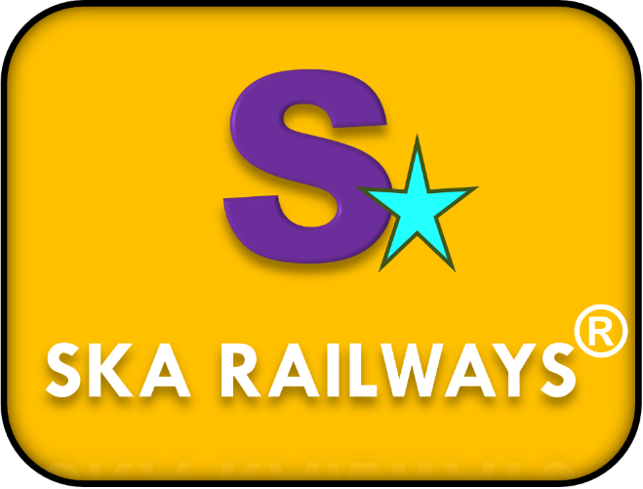

PROJECT ICON

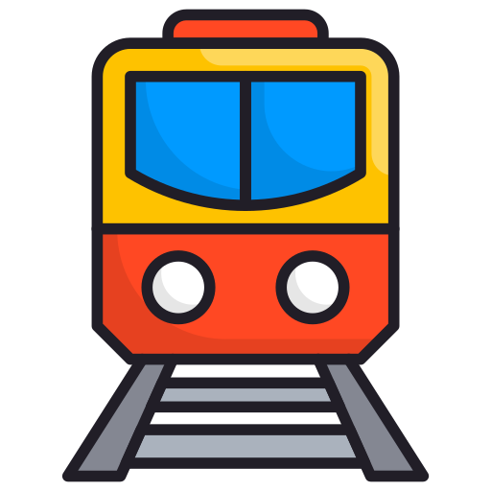

DECLARATION

I hereby declare that project report titled “SKA TRAIN TICKET RESERVATION SYSTEM” is an original work done BY ADEPU SAI KIRAN, for the During Month May To October 2023. With the best of my knowledge and belief.

Abstract

The SKA Train Ticket Reservation System is an application for maintaining a person's Journey History Booking a Train Ticket. In this project I tried to show the How working a Train Reservation system and cover the basic functionality of a Train Reservation System. To develop a project for solving financial applications of a customer in Train Reservation environment in order to nurture the needs of an end Train Reservation user by providing various ways to perform Reservation tasks. Also, to enable the user’s workspace to have additional functionalities which are not provided under a conventional Train project. This is undertaken as a project is based on relevant technologies. The main aim of this project is to develop software for Train Ticket Reservation System. This project has been developed to carry out the processes easily and quickly, which is not possible with the manuals systems, which are overcome by this software. This project is developed using HTML, CSS, JAVA SCRIPT, JSP and Oracle MYSQL use for database connection. Creating and managing requirements is a challenge of IT, systems and product development projects or indeed for any activity where you have to manage a contractual relationship. Organization needs to effectively define and manage requirements to ensure they are meeting needs of the customer, while proving compliance and staying on the schedule and within budget. The impact of a poorly expressed requirement can bring a business out of compliance or even cause injury or death. Requirements definition and management is an activity that can deliver a high, fast return on investment. The project analyses the system requirements and then comes up with the Requirements specifications. It studies other related systems and then come up with system specifications. The system is then designed in accordance with specifications to satisfy the requirements. The system design is then implemented with MYSQL, JSP, JAVA and HTML. The system is designed as an interactive and content management system. The content management system deals with data entry, validation confirm and updating whiles the interactive system deals with system interaction with the administration and users. Thus, above features of this project will save Ticket transaction time and therefore increase the efficiency of the system.

INDEX PAGE

1. Introduction 4

2. AIM of the Project 5

3. Index/Main UI Page of Train booking 6

4. What to Expect/Modules of Project 6

5. System Requirements 8

6. Software & Hardware Requirements 10

7. System Design 12

8. Project Architecture Diagram 14

9. Use-Case Diagram 15

10. The Security Terms 17

11. Train Reservation Terms 18

12. Customer Obligations 20

13. Do’s & Don’ts 20

14. Beware of Phishing 21

15. Project Hierarchy 22

16. Project Screenshots 24

17. Project Scheduling 38

18. Benefits Booking Ticket 39

19. Feature Look 40

20. Conclusion 42

21. Versions 43

22. New System Architecture 45

23. Project Screenshots 46

24. Reference 48

INTRODUCTION

The “SKA TRAIN RESERVATION SYSTEM” project is a model Internet Train Ticket Reservation. This site enables the customers/Users to perform the Booking a Train Ticket by sitting at their office or at homes through PC or laptop. The system provides the access to the customer to create an account, Book a Train Ticket Which The User Want From his account, also to view reports of all journey List present. The customers can access the this website for viewing their Account details and perform the booking transactions on account as per their requirements. With Internet Booking, the structure of the traditional Train Booking gets converted into an Online Booking model, thereby giving a concept of virtual booking a real shape. Thus, today's Booking is no longer confined to branches. E-Booking facilitates train Booking transactions by customers round the clock globally. Anybody who is an Account holder in this Registered user can become a member of Train Booking Management System. He has to fill a form with his personal details Now to keep the belief and trust of customers, there is the positive need for management of the Train Reservation, which can handle all this with comfort and ease. Smooth and efficient management affects the satisfaction of the customers and staff members, indirectly. And of course, it encourages management committee in taking some needed decision for future enhancement of the Train reservation. Now a day’s, managing a booking is tedious job up to certain limit. So software that reduces the work is essential. Also, today’s world is a genuine computer world and is getting faster and faster day-by-day. Thus, considering above necessities, the software for Train Booking has become necessary which would be useful in managing the train booking more efficiently. All transactions are carried out online by transferring from accounts in the same booking system or international train booking. The software is meant to overcome the drawbacks of the manual system.

Synopsis

SKA TRAIN TICKET RESERVATION SYSTEM keeps the day-by-day tally record as a complete booking system. It can keep the information of Account opening form, booking a train ticket, Raising the Feedback, updating mobile number, updating the password.

AIM of The Project

The main aim of designing and developing this Train ticket Reservation System with Programming Domain of JAVA JSP (Java Server Pages) Which will run by A server Apache Tomcat, primarily based Engineering project is to provide secure and efficient net booking facilities to the train ticket booking customers over the internet. Apache Server Pages, MYSQL database used to develop this application where all train customers can login through the secured web page by their account user id, user name and password. Users will have all options and features in that application like get journey history, feedback as well.

The Main Purpose

Main Purpose the Traditional way of maintaining details of a user in a Train reservation was to enter the details and record them. Every time the user needs to perform some booking transaction, he has to go to railway station and perform the necessary actions, which may not be so feasible all the time. It may be a hard-hitting task for the users and the Train Station Admins too. The project gives real life understanding of How Online Train Ticket System and activities performed by various roles in the supply chain. Here, we provide automation for Train Booking system through Internet. Online Train booking System project captures activities performed by different roles in real life train booking which provides enhanced techniques for maintaining the Train Reservation Database and Server.

THE PROCESS/HIERACHY

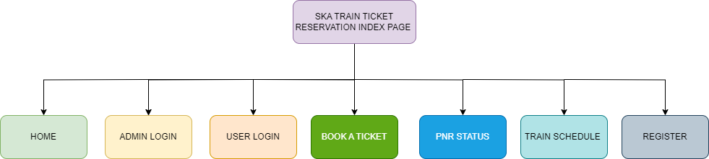

The Index Page of SKA TRAIN TICKET RESERVATION SYSTEM

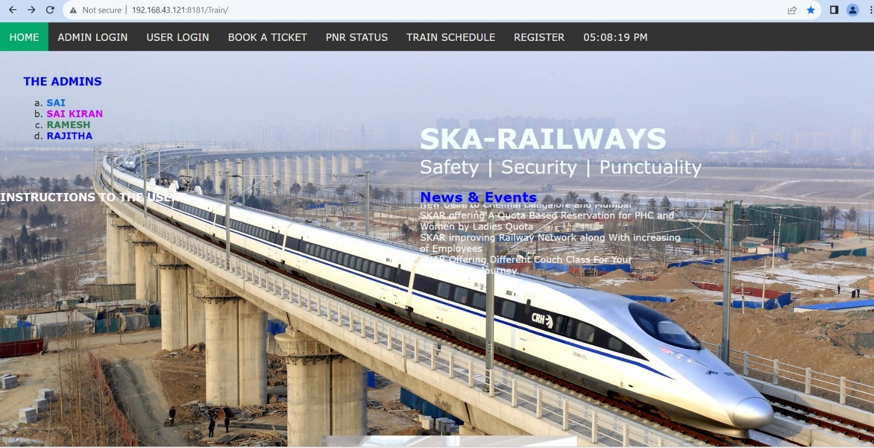

There are Mainly Three Modules

1 The Train Admin

2 The Train User

3 The New User Register

What to expect/Modules

Here are some of the features available through Train Reservation For Train Admin:

1. Train Admin: First Admin of the Train login with user name and password with a specified credentials which will maintained by a Train Database after a successful login Admin will Perform the Following Operations

There are 3 Sub main modules for Train Admin.

* 1. The Train Admin Module

1. Add New Train
2. Add new Station& Fare
3. Change Train Fare
   1. Train Module
4. Reservation
5. General Ticket
6. Print Ticket
7. Train Schedule
8. PNR Enquiry
9. Train Enquiry
   1. Feedback Module
10. View Feedback
11. Delete Feedback

The admin can do a logout the session as shown the below.

LOGIN PAGE OF TRAIN ADMIN

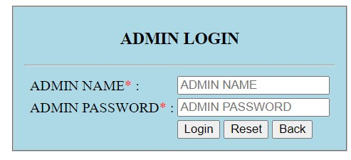

After A Successful Login Train Admin Gets a Admin UI

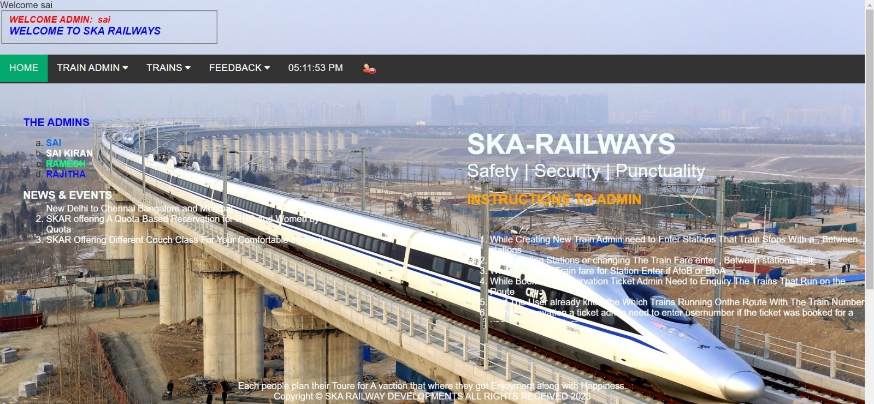

1. The Train User: First User login with user number, user name and password with a specified credentials which will maintained by a train Database after a successful login train user will Perform the Following Operations

There are 2 Sub main modules for Train User

* 1. Trains

1. Book a Ticket
2. PNR Status
3. Print/Download Ticket
4. Train Schedule
   1. Manage Account
5. View Journeys
6. Update Password
7. Update Mobile Number
8. Feedback

LOGIN PAGE OF TRAIN USER

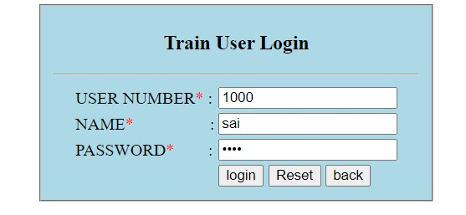

After A Successful Login Train User Gets User UI

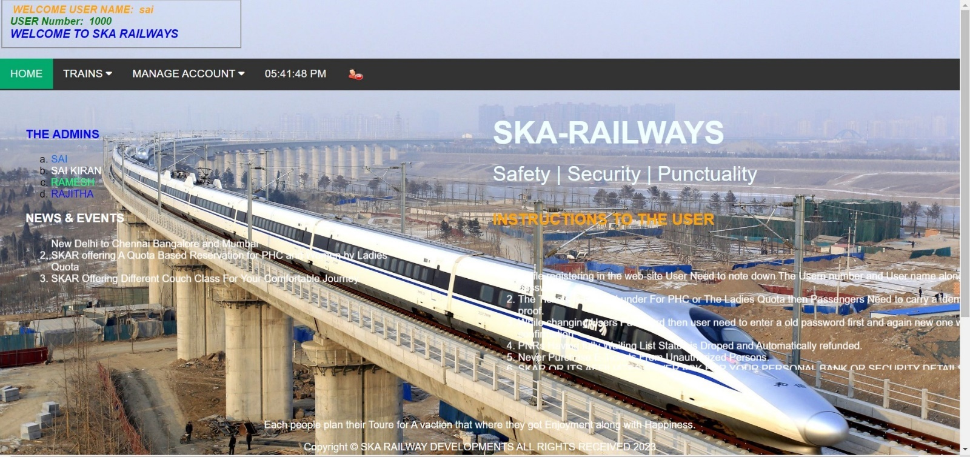

1. New Train User: The outside of Users can Register themselves to the train Database.

UI of New User Register

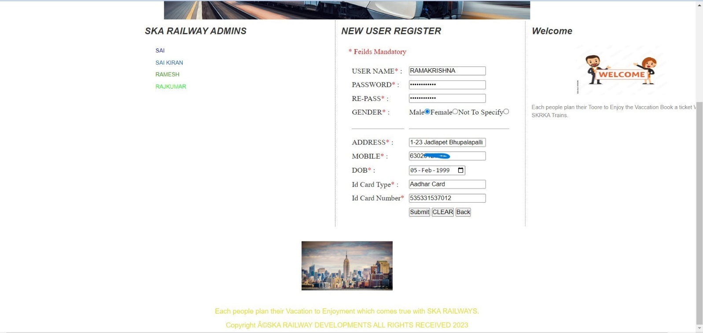



The New User details/credentials validated by Train DB

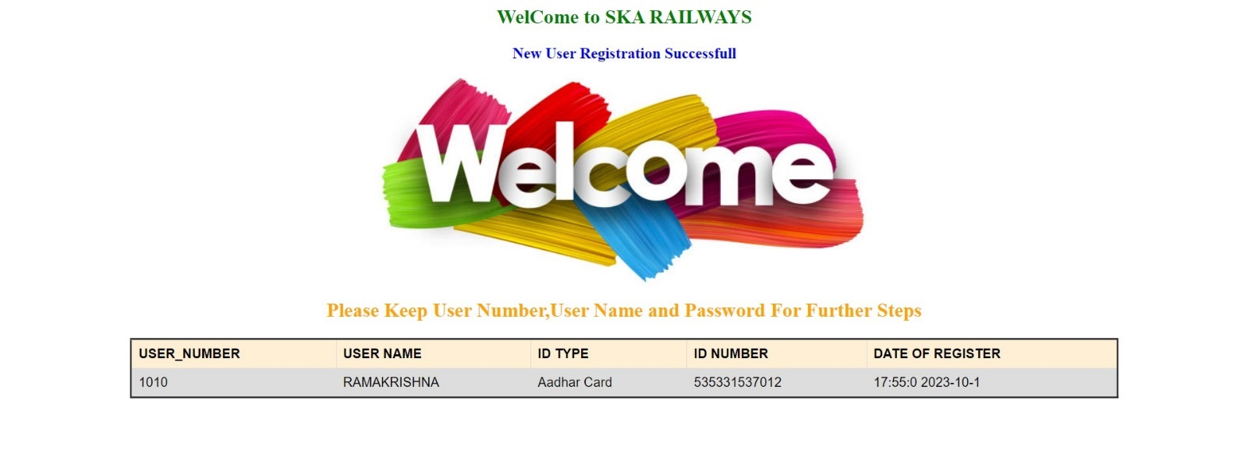

SYSTEM REQUIREMENTS

To be used efficiently, all computer software needs certain hardware components or other software resources to be present on a computer. These pre requirements are known as (computer) system requirements and are often used as a guideline as opposed to an absolute rule. Most software defines two sets of system requirements: Minimum and Recommended. With increasing demand for higher processing power and resources in newer versions of software, system requirements tend to increase over time. Industry analysts suggest that this trend plays a bigger part in driving upgrades to existing computer systems than technological advancements. A second meaning of the term of system requirements is a generalization of this first definition, giving the requirements to be met in the design of a system or sub-system.

SOFTWARE REQUIREMENTS

Front End/Language: HTML5, CSS3

Domain: JAVA, JSP

Back End/Database: SQL

Web Server: Apache Tomcat 10

Server logs: XML

Operating System: Windows 7,10,11

HARDWARE REQUIREMENTS

Processor: Intel Core 2Duo – Later Generations i3, i5, i7, i9 Individual Generations

Main Memory (RAM): 4 GB

Hard Disk (Storage): 256 GB

Monitor: inch Colour Monitor

Mouse: Optical Mouse

FUNCTIONAL REQUIREMENTS

A Functional Requirements Specification describes what is required to meet the admin/users' business needs. Functional requirements specify which actions the design must provide in order to benefit the system's Admin/users. Functional requirements are determined by the needs, user, and task analysis of the current system.

* Must have valid Admin/user-id and password to login to the system.
* If a wrong password Admin/user is given thrice in succession, that Server will mark them as unauthorized persons
* It defines the function of a system or its components where function is described as a specification of behaviour between inputs and outputs.

IF an Admin/Users will enter wrong Credentials/Copy the direct URL of the legginged session then Server treats them as Un-Authorized Persons

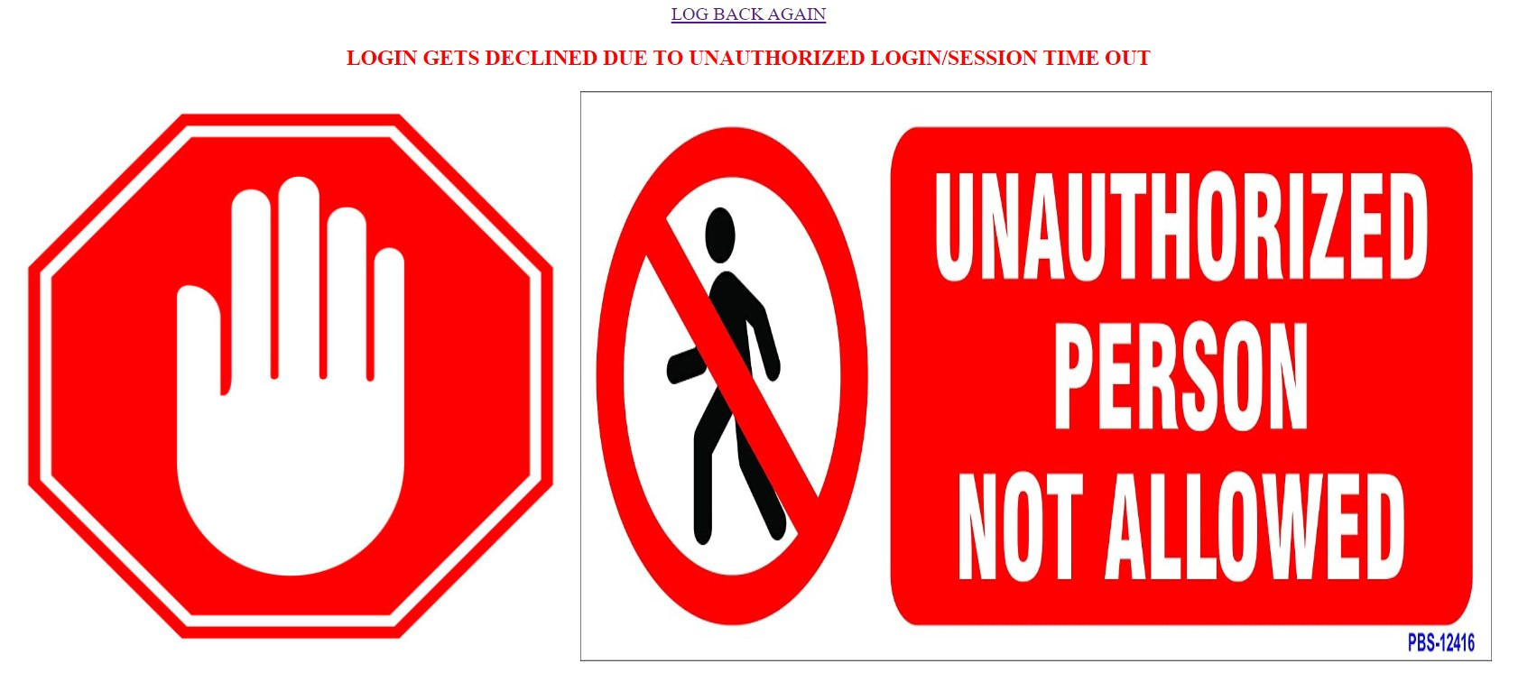

NON-FUNCTIONAL REQUIREMENTS

Non-functional requirements are requirements that are not directly concerned with the specific functions delivered by the system. ... Non-functional requirements needed in this internet Train booking system are identified as performance requirements, safety requirements, security requirements and software quality attributes.

* Secure for confidential data (Admin/user details)
* It is identified as performance, safety, security requirements and software quality attributes

SYSTEM DESIGN

1. Steps of System design for User in SKA Train Ticket Reservation System are as follow:

* Firstly, the Admin/User needs to request the URL of Train Reservation Server.
* User/Admin need to enter his/her credentials in the login page, then the system checks User ID and Pin No. After the system check User ID and Pin No, then the system check that this customer is valid or not.
* If it is valid, Main Menu Page of the Internet train booking website. Then the customer can choose from many menus such as viewing Journey, Book a Ticket, Train Schedule, Update Customer Profile and so on.
* For example, if the customer chooses the train booking menu, then the customer needs to Source (From) and Destination (To) with Specific Dates and Couch Class. After that, submit this information to the system. And then ensure the detailed information and click Confirm button to accomplish the ticket booking. Key in his/her TTRS Secure PIN to complete this transaction After logout, customer needs to clear cache for security reason.

1. Steps of System design for Train Admin in SKA Train ticket Reservation are as follow:

* Firstly, the Admin to request the URL of Train Reservation Server.
* Admin need to enter Their Credentials then the system checks Admin ID and Pin No. After the system check ID and Pin No, then the system check that this Admin is valid or not.
* If it is valid, Admin UI Menu Page of the Train Reservation website. Then the Admin can choose from many menus such as Add New Train, Add New Station, Modify Train Ticket Fare, View PNR Status (Admin), Admin Train Reservation, Train Schedule, general Ticket, Print/Download Ticket so on.
* For example, if the admin chooses the PNR menu, then the admin needs to select PNR Number then submit this information to the system. And then ensure the detailed information and click Confirm button to accomplish the transaction.

System design goes through two phases of development:

1. Logical Design and
2. Physical Design.

1)Logical Design

The logical flow of a system and define the boundaries of a system. It includes the following steps:

* Reviews the current requirements of project system – its data flows, file content, volumes, frequencies etc.
* Prepares output specifications – that is, determines the format, content and frequency of reports.
* Prepares input specifications – format, content and most of the input functions.
* Prepares edit, security and control specifications.
* Specifies the implementation plan.
* Prepares a logical design walk through of the information flow, output, input, controls and implementation plan.
* Reviews benefits, costs, target dates and system constraints.

2)Physical Design

Physical system produces the working systems by define the design specifications that tell the programmers exactly what the candidate system must do. It includes the following steps.

* Design the physical system.
* Specify input and output media.
* Design the database and specify backup procedures.
* Design physical information flow through the system and a physical design Walk through.
* Plan system implementation.
* Prepare a conversion schedule and target date.
* Determine training procedures, courses and timetable.
* Devise a test and implementation plan and specify any new hardware/software.
* Update benefits, costs, and conversion date and system constraints.

SKA TRAIN TICKET RESERVATION ARCHITECTURE DIAGRAM

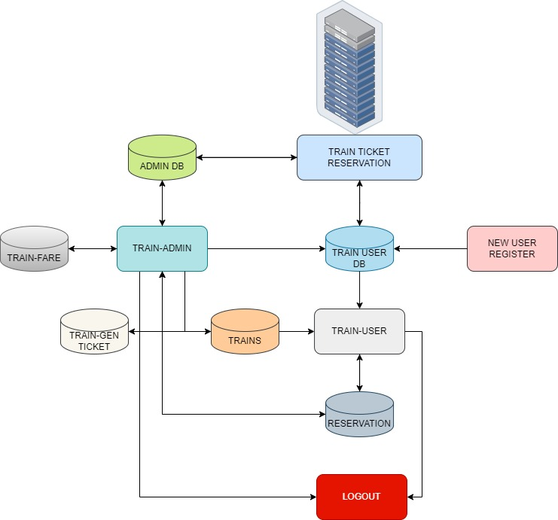

The System Design Process

* The SKA TRAIN RESERVATION Server will be a Centralised Server that keeps all Admins/users at a systematic way
* The TRAIN ADMINS will be validated by the database called Train-admin Db if the Train admin enters wrong credentials, then the Train Reservation Server treated them as Un authorized admins in the Train Booking system
* And the Train users are validated by the train-users DB if the train user enters the wrong credentials of then the server treated them as a un authorized persons in the Website
* The outside of the users of a bank server can Register for a new AC and it will be manged and validated by train admin

USE CASE DIAGRAM

The purpose of use case diagram is to capture the dynamic aspect of a system. However, this definition is too generic to describe the purpose, we will look into some specific purpose, which will distinguish it from other four diagrams. Use case diagrams are used to gather the requirements of a system including internal and external influences. These requirements are mostly design requirements. Hence, when a system is analysed to gather its functionalities, use cases are prepared and actors are identified. When the initial task is complete, use case diagrams are modelled to present the outside view. In brief, the purposes of use case diagrams can be said to be as follows

* + Used to gather the requirements of a system.
  + Used to get an outside view of a system.
  + Identify the external and internal factors influencing the system.
  + Show the interaction among the requirements are actors. Online booking system has two use case diagrams: • Use case diagram for admin. • Use case diagram for user.

Use case Diagram for Train Admin

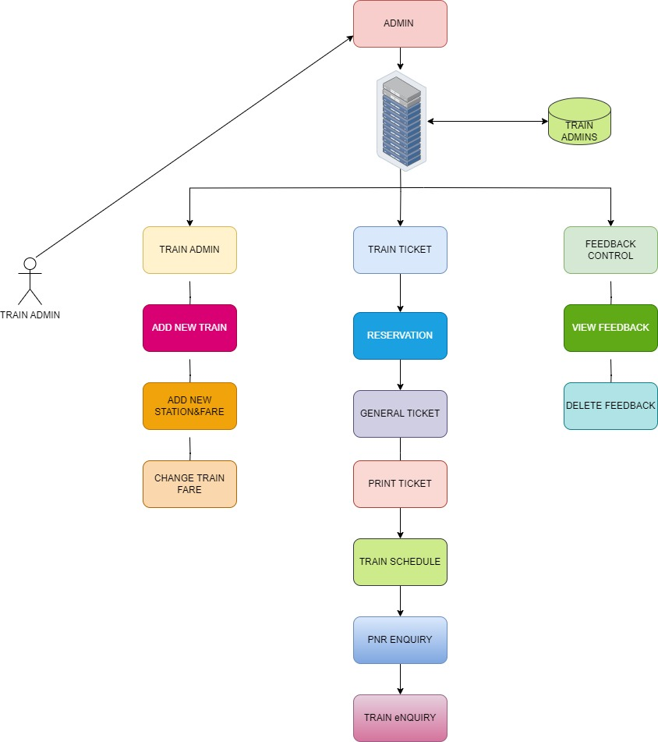



Use Case Diagram for Train User

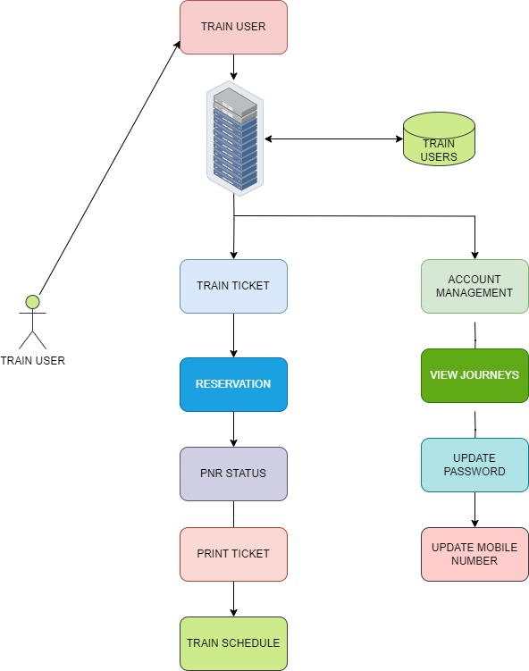

Security terms

1. The Train Database where the user/admin maintains his/her account will assign: a) User Account Number & user name b) Password

2. The User-id and Password given by the Train must be replaced by User Name and Password of customer’s choice at the time of first log-on. This is mandatory.

3. Train Admin will make reasonable use of available technology to ensure security and to prevent unauthorized access to any of this service, that it is a secure site. It means that • You are dealing with RR at that moment. • The two-way communication is secured, which ensures the confidentiality of the data during transmission.

4. You are welcome to access This Train ticket from anywhere anytime. However, as a matter of precaution, customers may avoid using PCs with public access.

5. There is an easy way to retrieve a password from the system. even, if a customer forgets his/her password, he/she must approach the branch Admin for re-registration.

Train Reservation terms

1. All requests received from customers are logged for backend fulfilment and are effective from the time they are recorded at the Train DB.

2. Rules and regulations applicable to normal Booking transactions in India will be applicable through this site.

3. The SKA Train Reservation service cannot be claimed as a right. The booking may also convert this into a discretionary service anytime.

|  |  |
| --- | --- |
| **Symbol** | **Description** |
| CAN / MOD | Cancelled or Modified Passenger |
| CNF / Confirmed | Confirmed (Coach/Berth number will be available after chart preparation) |
| RAC | Reservation Against Cancellation |
| WL # | Waiting List Number |
| RLWL | Remote Location Wait List |
| GNWL | General Wait List |
| PQWL | Pooled Quota Wait List |
| REGRET/WL | No More Booking Permitted |
| RELEASED | Ticket Not Cancelled but Alternative Accommodation Provided |
| R# # | RAC Coach Number Berth Number |
| WEBCAN | Railway Counter Ticket Passenger cancelled through internet and Refund not collected |
| WEBCANRF | Railway Counter Ticket Passenger cancelled through internet and Refund collected |
| RQWL | Roadside Quota Waitlist |
| DPWL | Duty Pass Waitlist |
| TQWL | Tatkal Quota Waitlist |
| NT | Passenger Not Turned Up |

TICKET TYPES/TERMS

1. GENERAL

* The Ticket that a purpose of the passengers without any extra cost as per Records

1. LADIES

* The Ticket that a purpose of the Ladies passengers with some deduction of cost as per Records but it validated while at Boarding the Train.

1. TATKAL

* The Ticket that a purpose of the passengers with Some extra cost of actual ticket price it will available before 10 hours of train start from origin/Source.

1. PREMIUM TATKAL

* The Ticket that a purpose of the passengers with Some extra cost of actual ticket price it will available before 10 hours of train start from origin/Source. As per Records

1. PHC

The Ticket that a purpose of the passengers with Physically Handicap with some deduction of cost as per Records but it validated while at Boarding the Train.

COUCH TYPES/TERMS

1. 1A – First Class AC

AC Tier-1 is the most expensive class of Railways. The ticket price of 1A coach is equivalent to the fare of an aeroplane. The AC-1 coaches have eight cabins, and the half AC first-class coach has three cabins. The coach has a staff to help passengers. Beds are included with the rent. These types of air-conditioned coaches only exist on popular routes, and they can carry 10 or 18 passengers. Sleeper berths are very wide in AC Tier-1 coaches.

1. 2A – Two-Tier AC

The tier-2 AC coach of the railways is also air-conditioned with sleeping berths. It has legroom, curtains and an individual reading lamp. There are two levels of six sections in tier-2 AC coaches. Four seats are spread across the width of the coach and two seats to the side. To take care of the privacy of passengers, there is a curtain in every seat. In a broad gauge ICF coach, about 46 passengers can travel while up to 52 passengers can travel in an LHB coach.

1. 3A- Three-Tier AC

This coach is also fully air-conditioned with sleeping berths. Although the seats in 3A coach are arranged in the same manner as 2AC, it has three tiers relative to its width and has two seats, i.e. eight seats in total in one coach. You don’t get the facility of the lamp of any kind to read. Also, the cost of the bedding provided in it is included in your fare. Sixty-four passengers travel in it. In broad gauge (ICF) coaches where 72 passengers can travel.

1. CC – Chair Car AC

CC or chair car coaches are also air-conditioned seater coaches, with only five seats in a row. Such coaches are best for day trips. Such coaches are used in Garib Rath, double-deckers and Shatabdi trains.

1. SL – Sleeper Class (Non-AC)

The sleeper class is the most common coach of Indian Railways, usually ten or more such coaches are added to a train. The coach has three berths in width and two in length, with 72 seats for passengers.

1. 2S – Second Sitting (Non-AC)

Second seating coaches are the lowest class coaches. It has seats for passengers only. A berth seats 3 passengers. It has 108 seats to sit in the LHB coach.

So, these are the travel classes in Indian trains. You can opt for any one of these as per your budget.

Customer’s obligations

1. The customer has an obligation to maintain secrecy in regard to Username & Password registered with the Bank. The bank presupposes that login using valid Username and Password is a valid session initiated by none other than the customer.

2. Transaction executed through a valid session will be construed by Server to have emanated from the registered customer and will be binding on him/her.

3. The customer will not attempt or permit others to attempt accessing the SKA Train Ticket Reservation through any unlawful means.

While registering in the web-site User Need to note down The User number and User name along with password

    The Tickets is Booked under For PHC or The Ladies Quota then Passengers Need to carry a identity proof.

    While changing Users Password then user need to enter a old password first and again new one with confirmation

    PNRs Having fully Waiting List Status is Dropped and Automatically refunded.

    Never Purchase E-Tickets From Unauthorized Persons.

    SKAR OR ITS AFFILIATES NEVER ASK FOR YOUR PERSONAL BANK OR SECURITY DETAILS

    In Case of Train is Delayed for 4 Hours Then Refund is Admissible.

    In Case of train cancellation on its entire Run Then Total RS/Fund Refunded To users Account Automatically

Dos & Don’ts

1. The customer should keep his/her User ID and password strictly confidential and should not divulge the same to any other person. Any loss sustained by the customer due to non-compliance of this condition will be at his/her own risk and responsibility and the SKA Train Reservation will not be liable for the same in any manner.

2. The customer is free to choose a password of his/her own for SKA Train Reservation services. As a precaution a password that is generic in nature, guessable or inferable personal data such as name, address, phone number, date of birth etc. is best avoided. Similarly, it is a good practice to commit the password to memory rather than writing it down somewhere.

3. It may not be safe to leave the computer unattended during a valid session. This might give access to your account information to others.

Safe Online Train Booking Tips

• URL address on the address bar of your internet browser begins with "https"; the letters at the end of "https" means 'secured'.

• Look for the padlock symbol either in the address bar or the status bar (mostly in the address bar) but not within the web page display area. Verify the security certificate by clicking on the padlock.

• Do not enter login or other sensitive information in any pop-up window.

• The address bar has turned to green indicating that the site is secured with security

Beware of Phishing Attacks

• Phishing is a fraudulent attempt, usually made through email, phone calls, SMS etc seeking your personal and confidential information.

• State Bank or any of its representatives never sends you email/SMS or calls you over phone to get your personal information, password or one time SMS (high security) password.

• Any such e-mail/SMS or phone call is an attempt to fraudulently withdraw money from your account through Internet Banking. Never respond to such email/SMS or phone call.

• Change your Internet Train Reservation/Banking password at periodical intervals.

• Always check the last log-in date and time in the post login page.

Scammers use email or text messages to try to steal your passwords, account numbers, or Social Security numbers. If they get that information, they could get access to your email, bank, or other accounts. Or they could sell your information to other scammers. Scammers launch thousands of phishing attacks like these every day — and they’re often successful.

Phishing emails and text messages often tell a story to trick you into clicking on a link or opening an attachment. You might get an unexpected email or text message that looks like it’s from a company you know or trust, like a bank or a credit card or utility company. Or maybe it’s from an online payment website or app. The message could be from a scammer, who might



THE SKA TRAIN RESERVATION SYSTEM HIERACHY/PROCESS

SKA TRAIN RESERVATION SYSTEM INDEX

* MAIN INDEX PAGE



* ADMIN PAGE



* USER PAGE



PROJECT SCREENSHOTS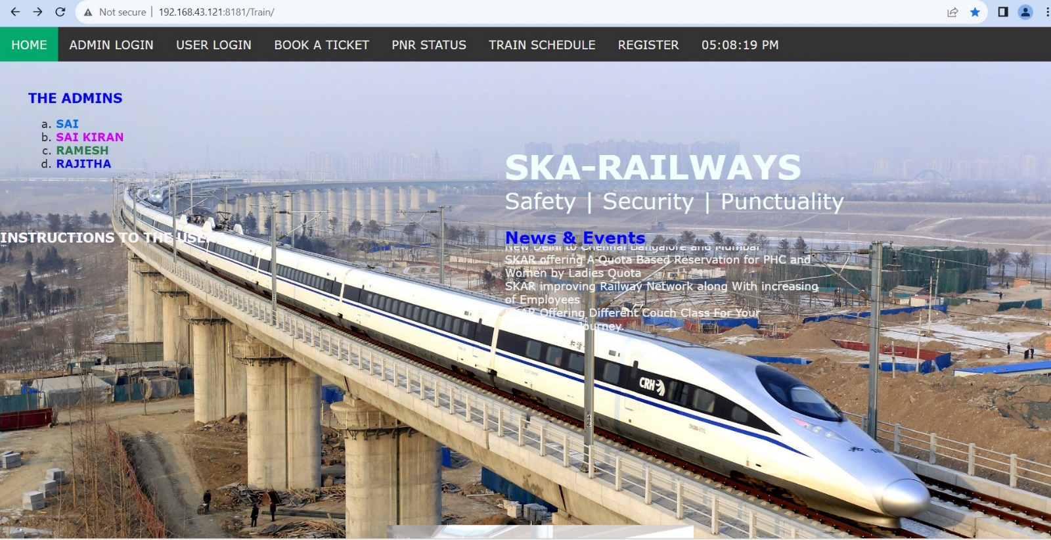

INDEX PAGE

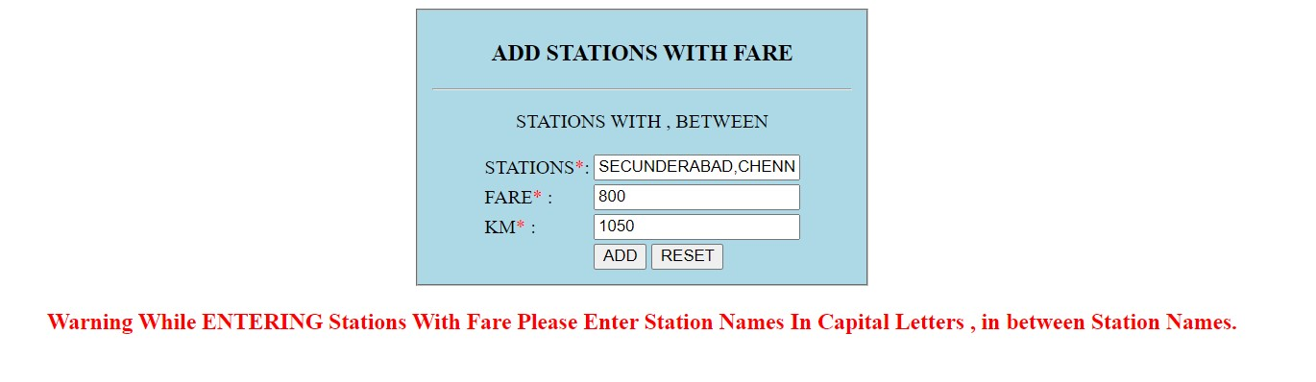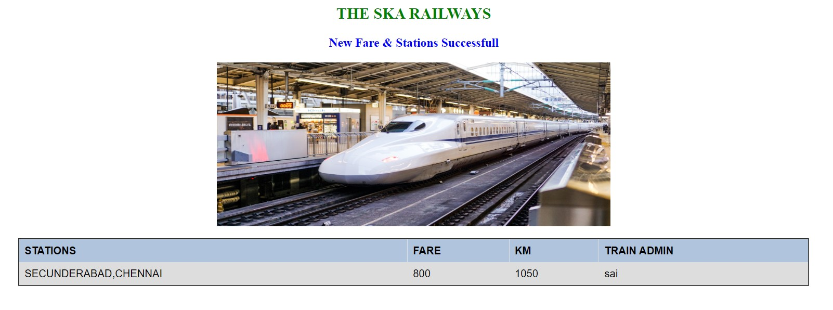

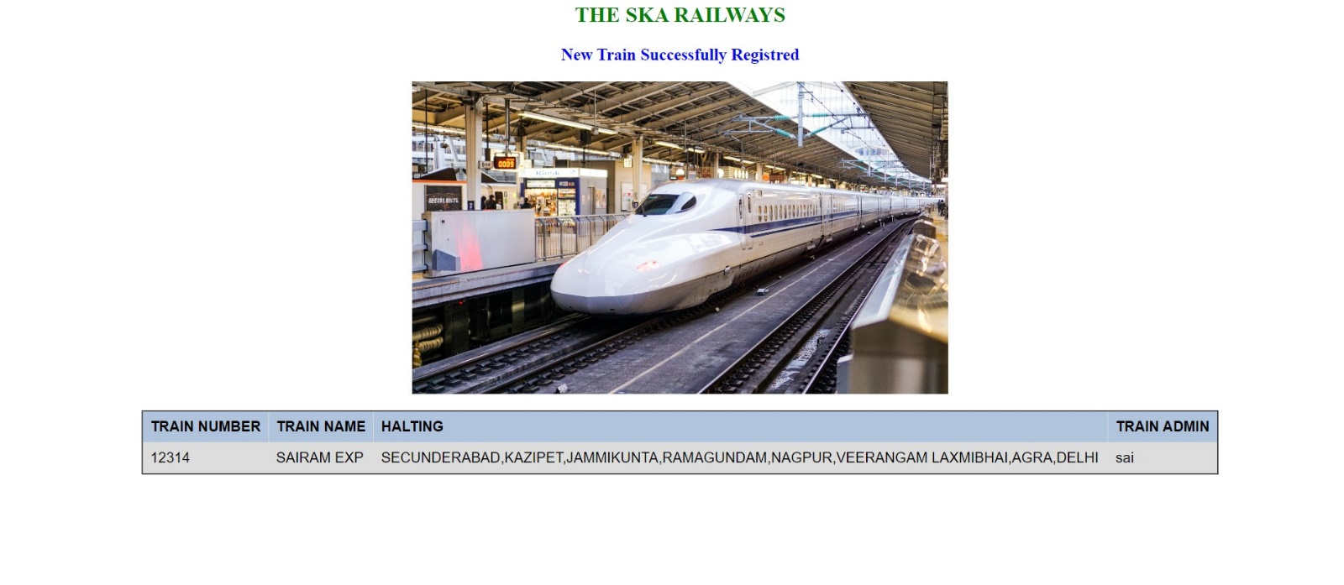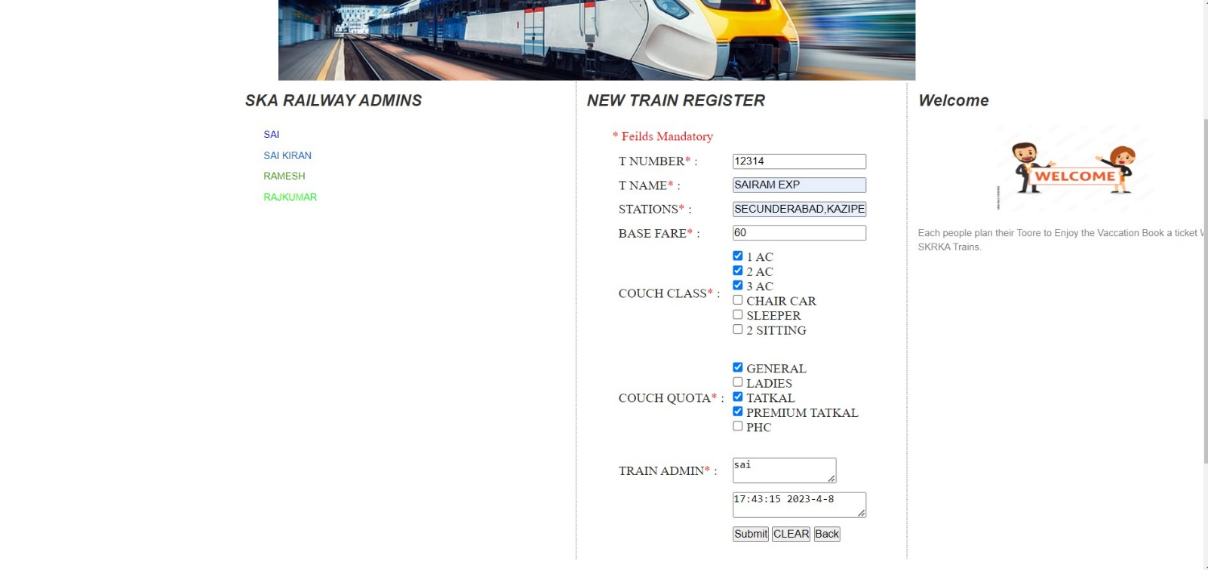

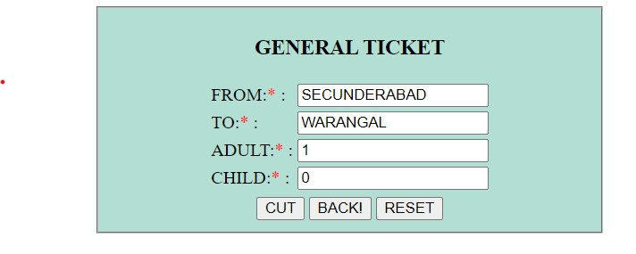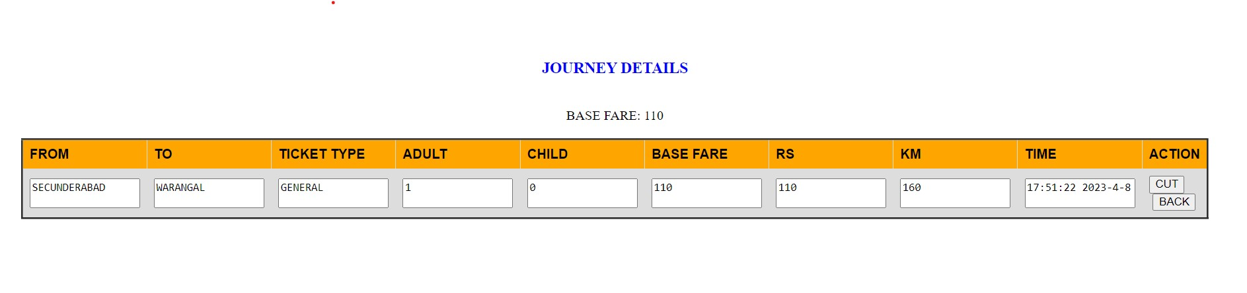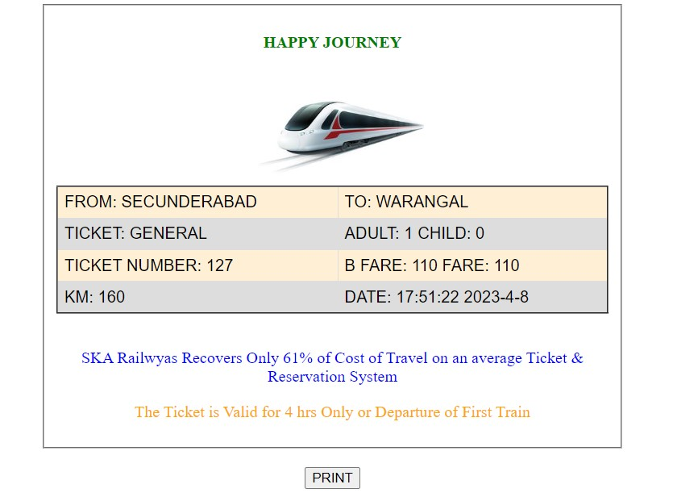

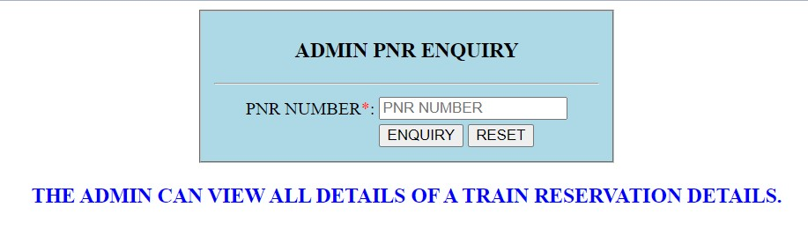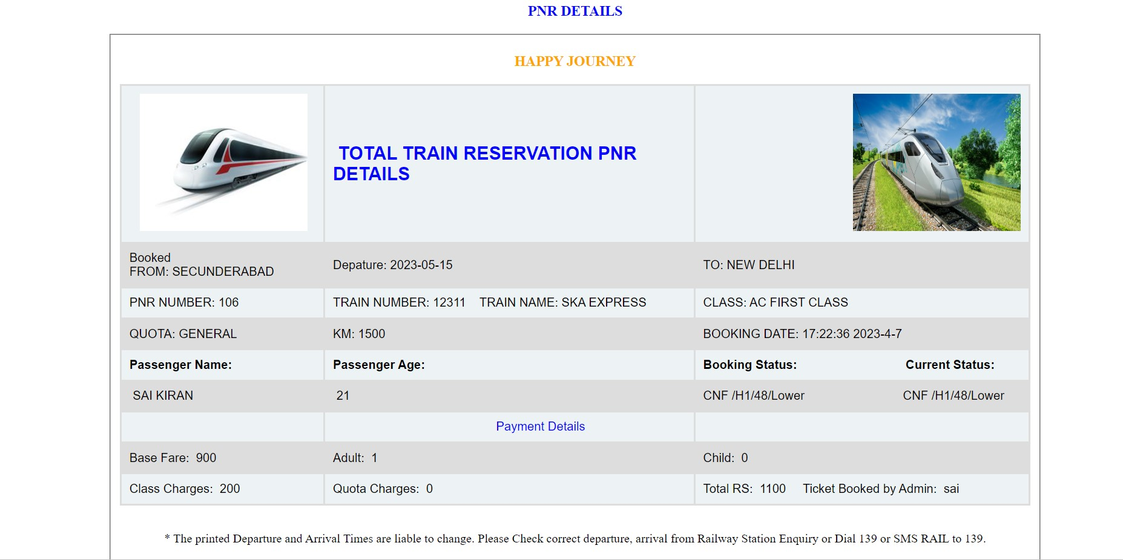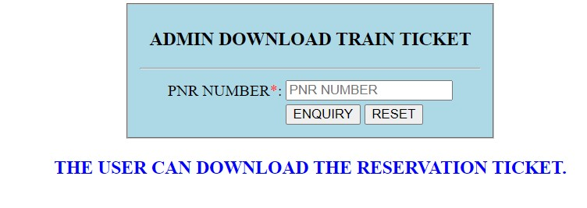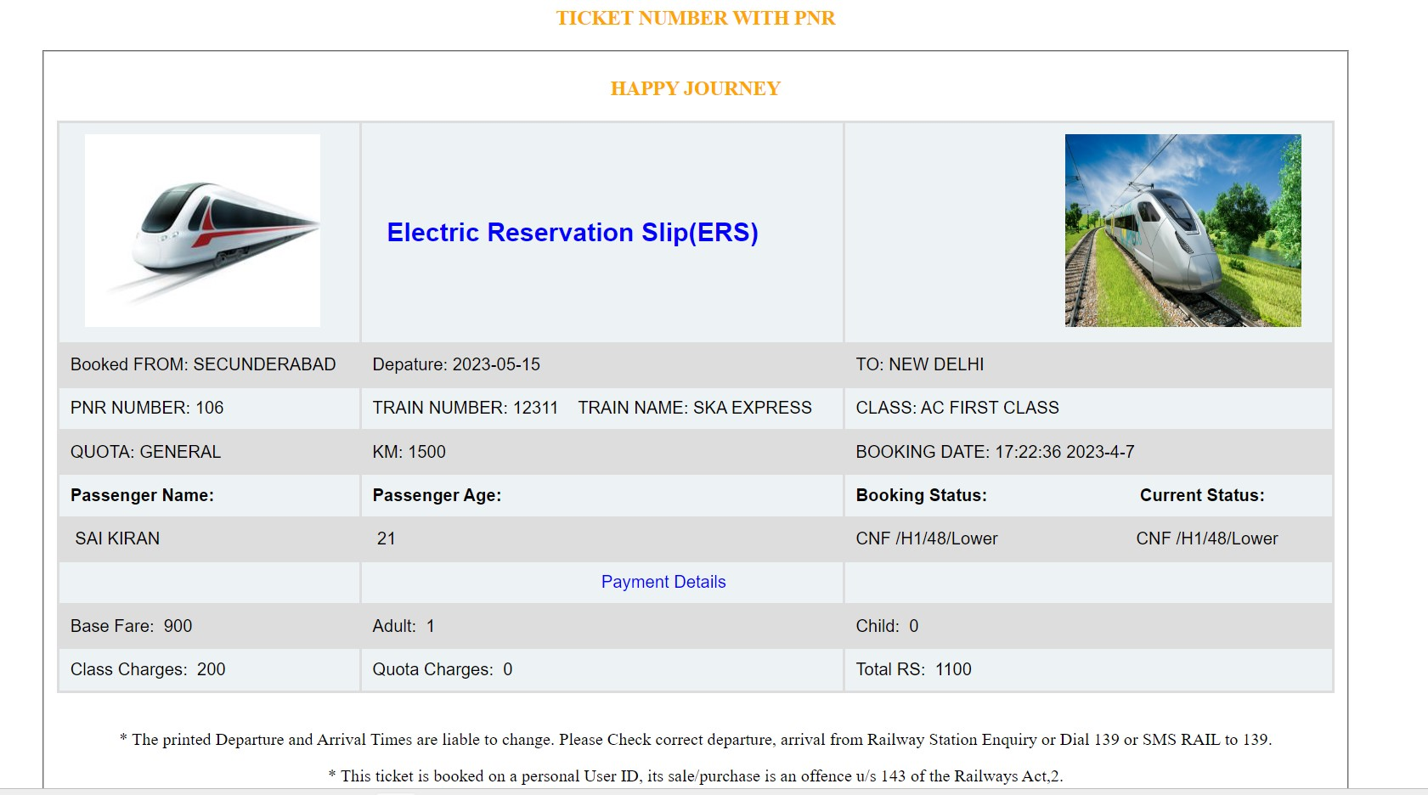

TICKET RESERVATION

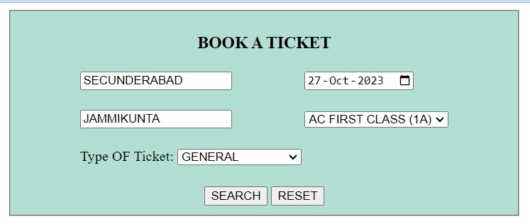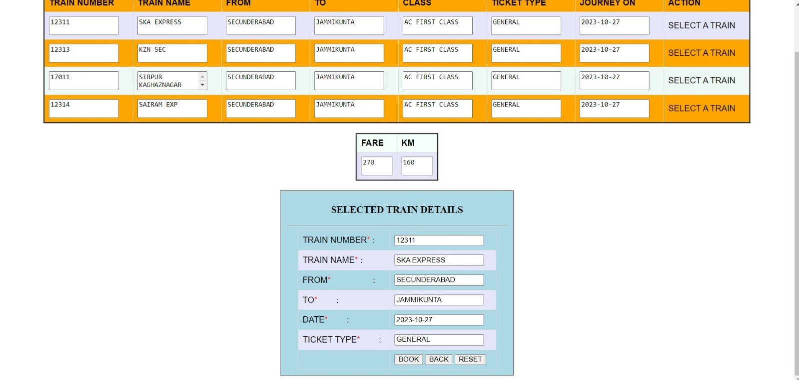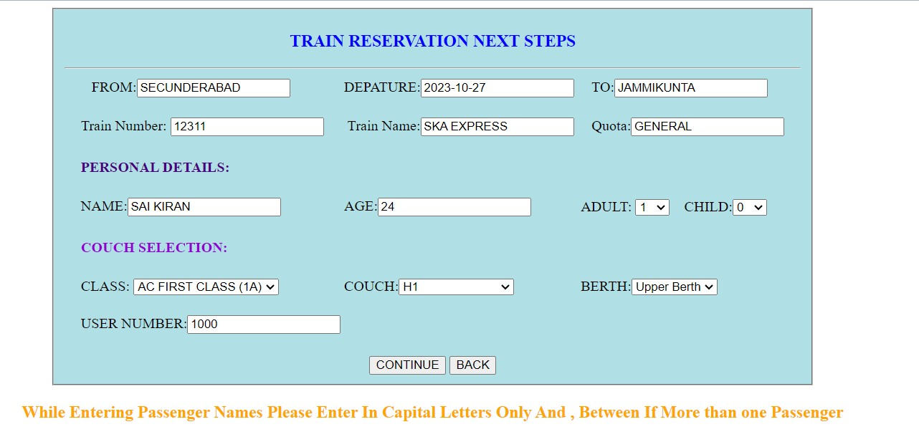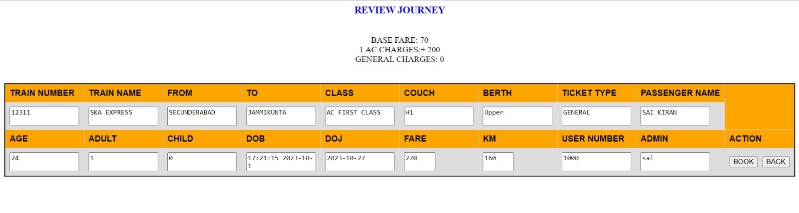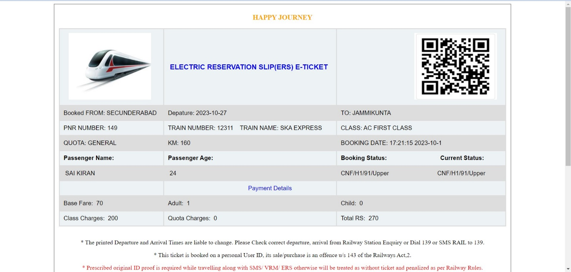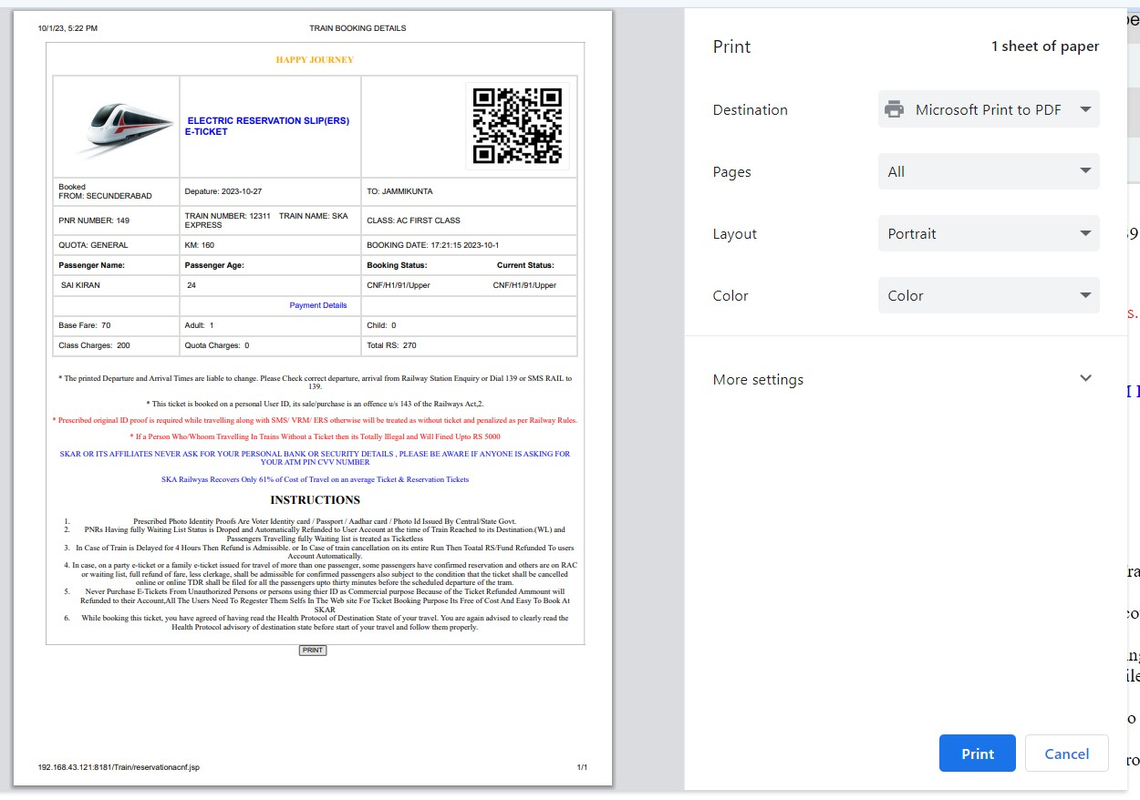

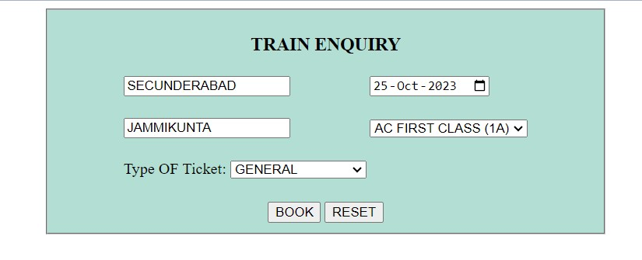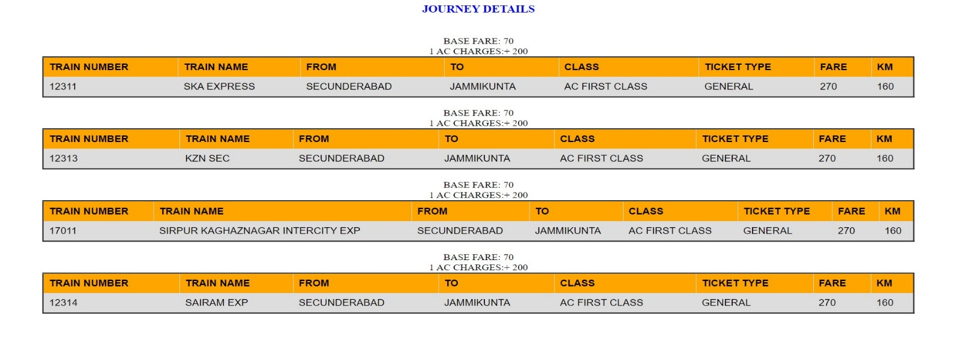



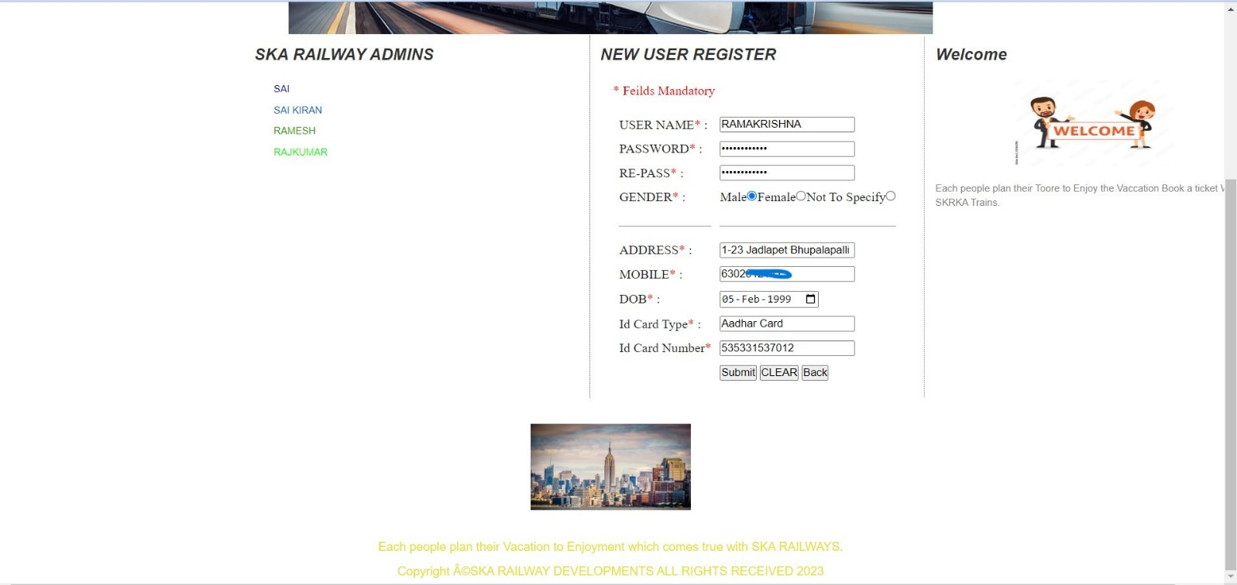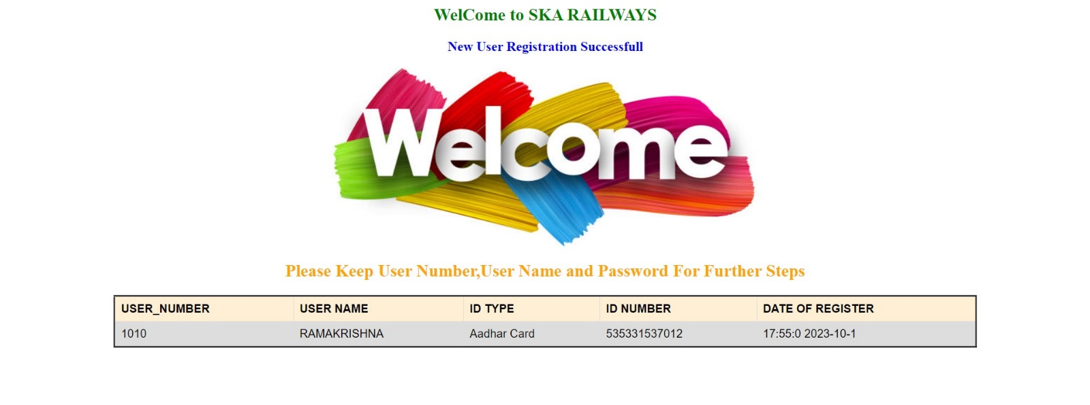



USER UI INDEX

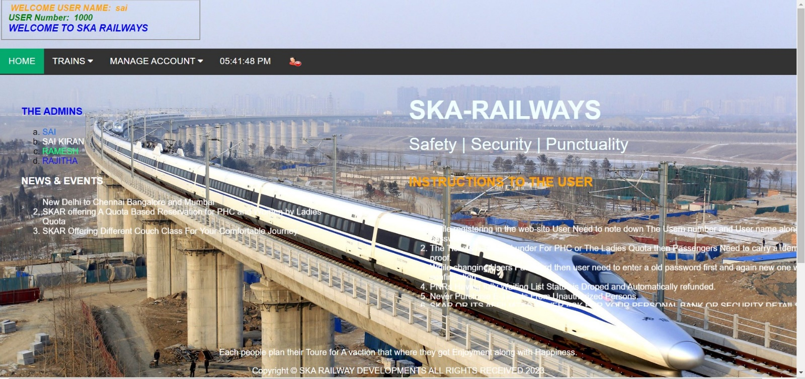

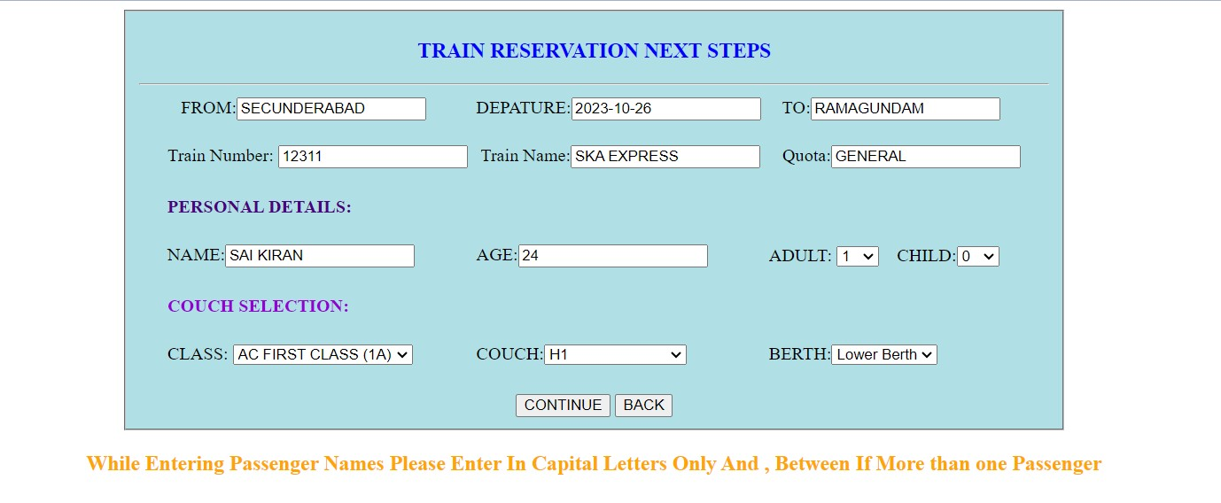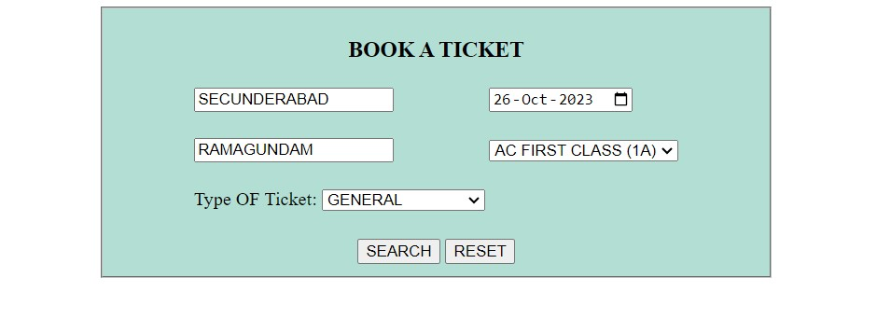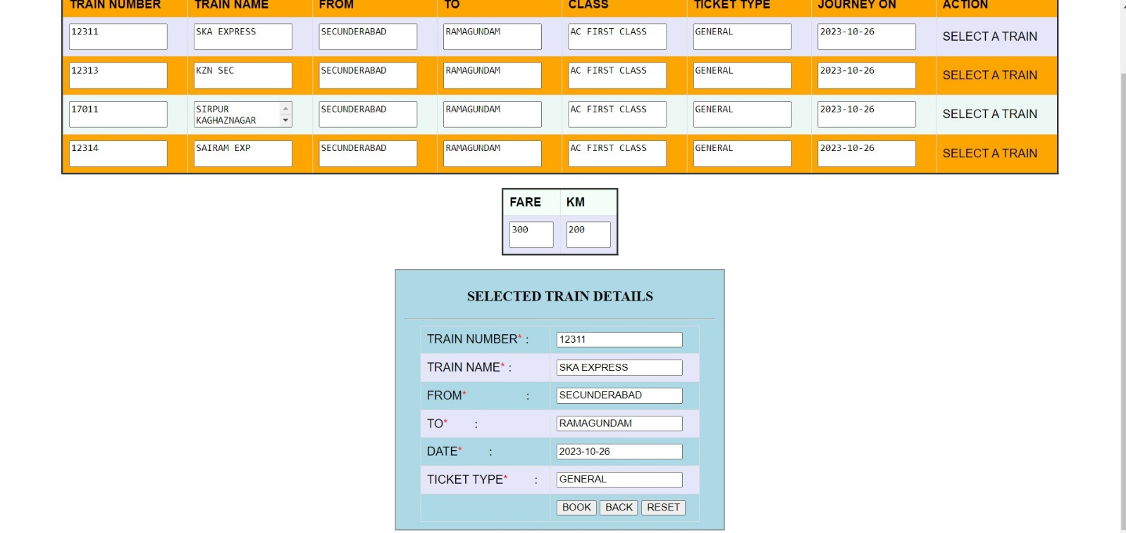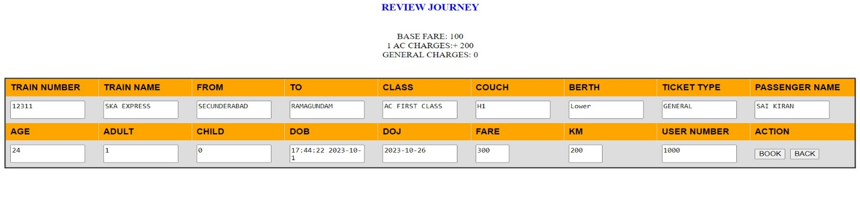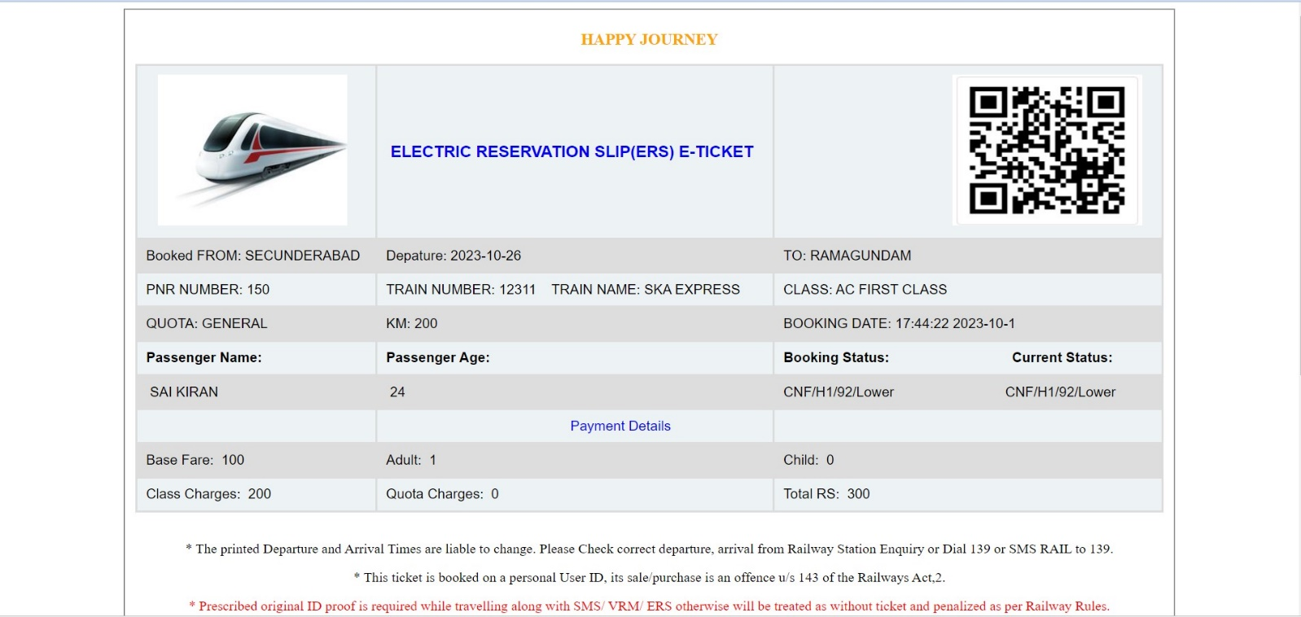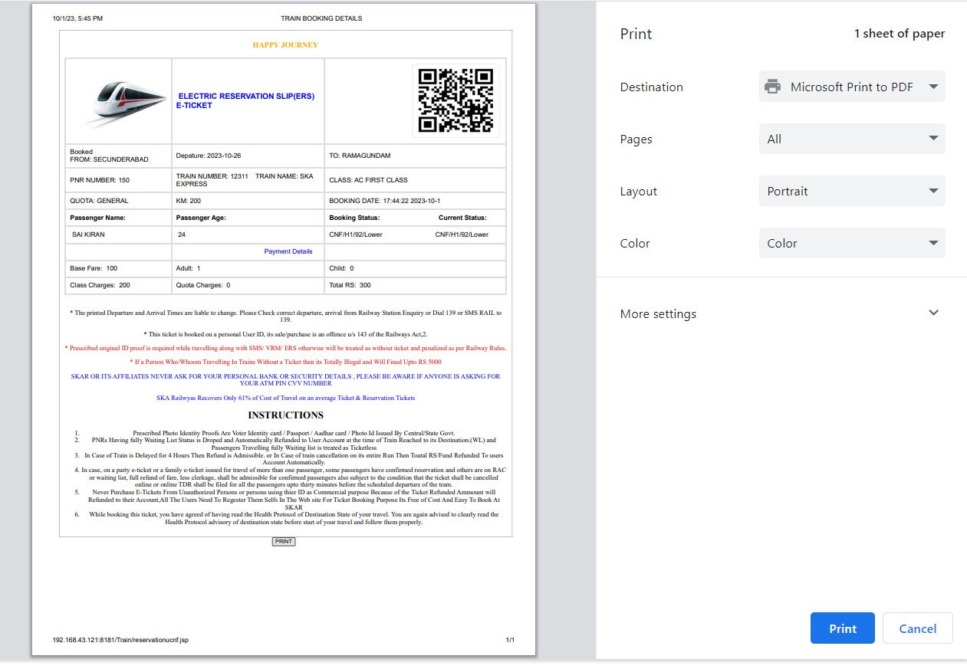

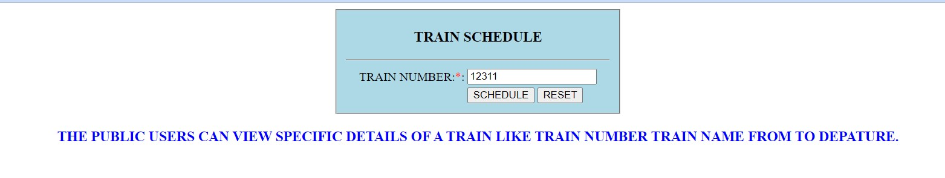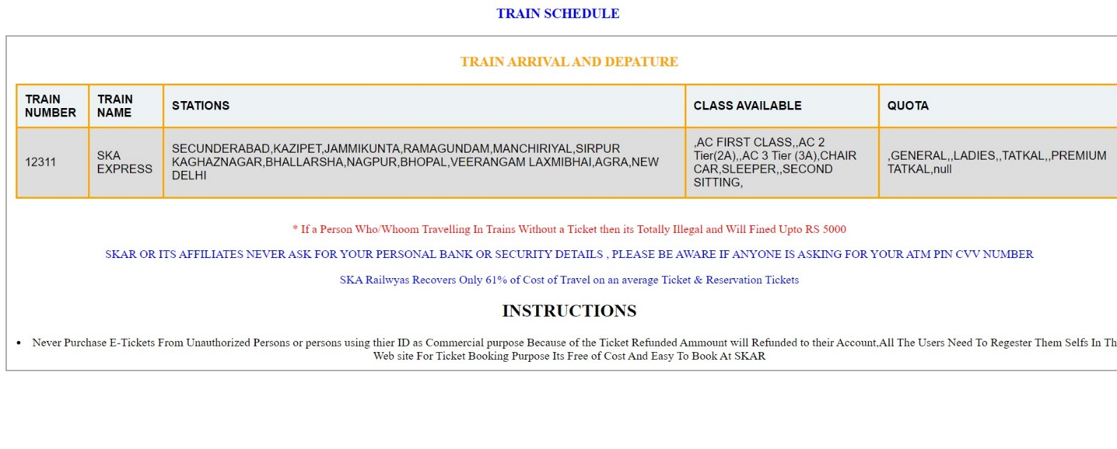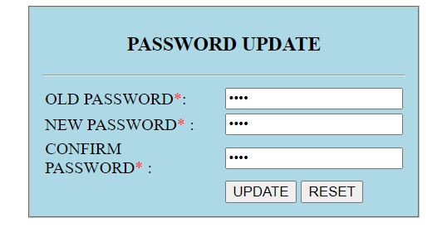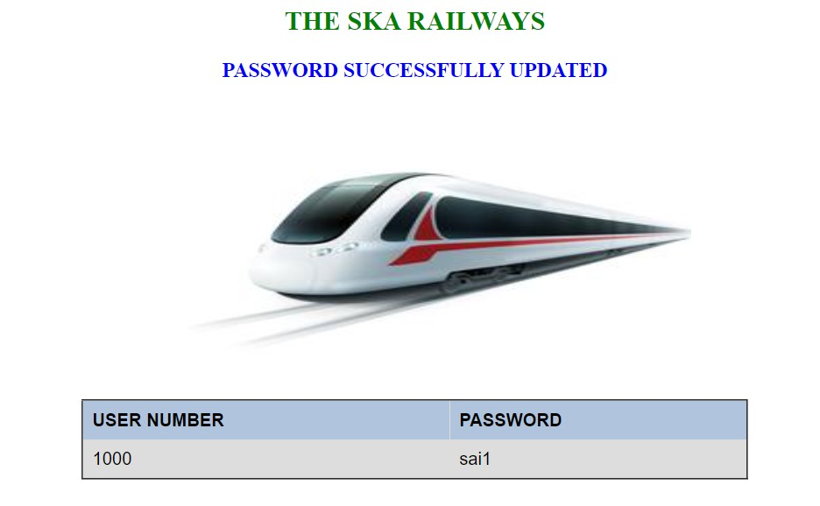

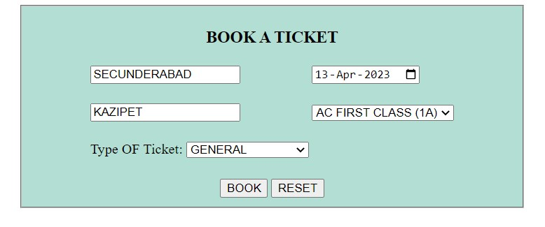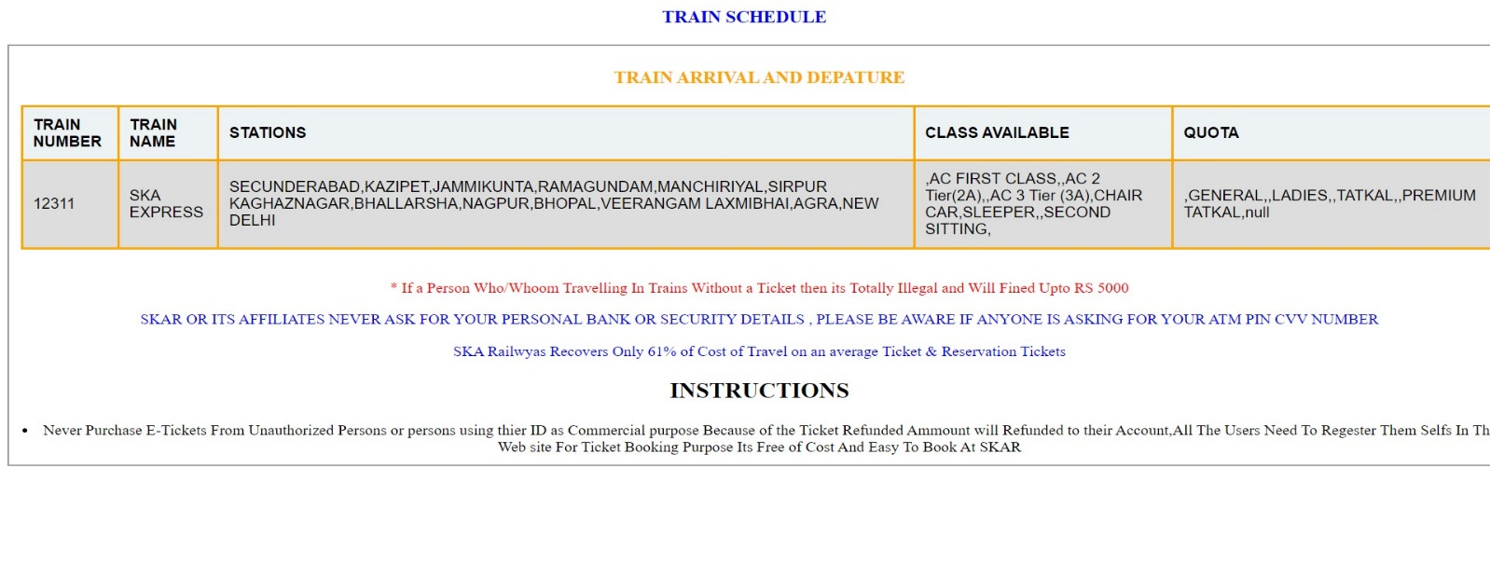

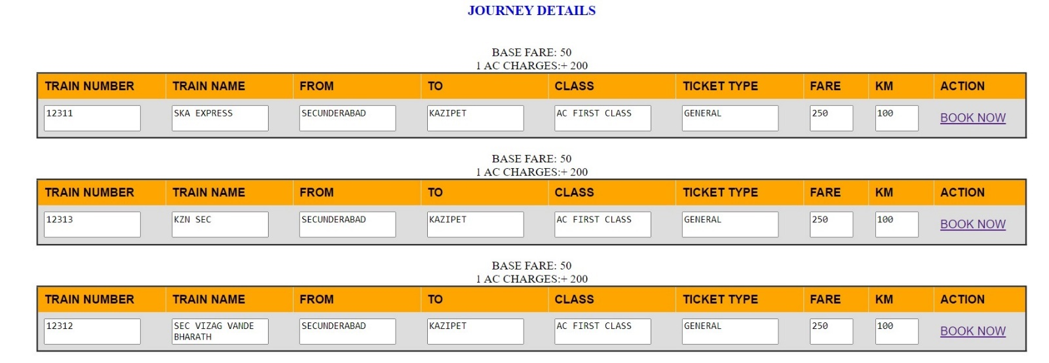

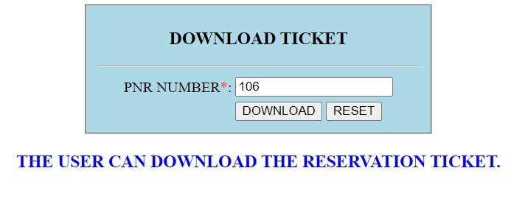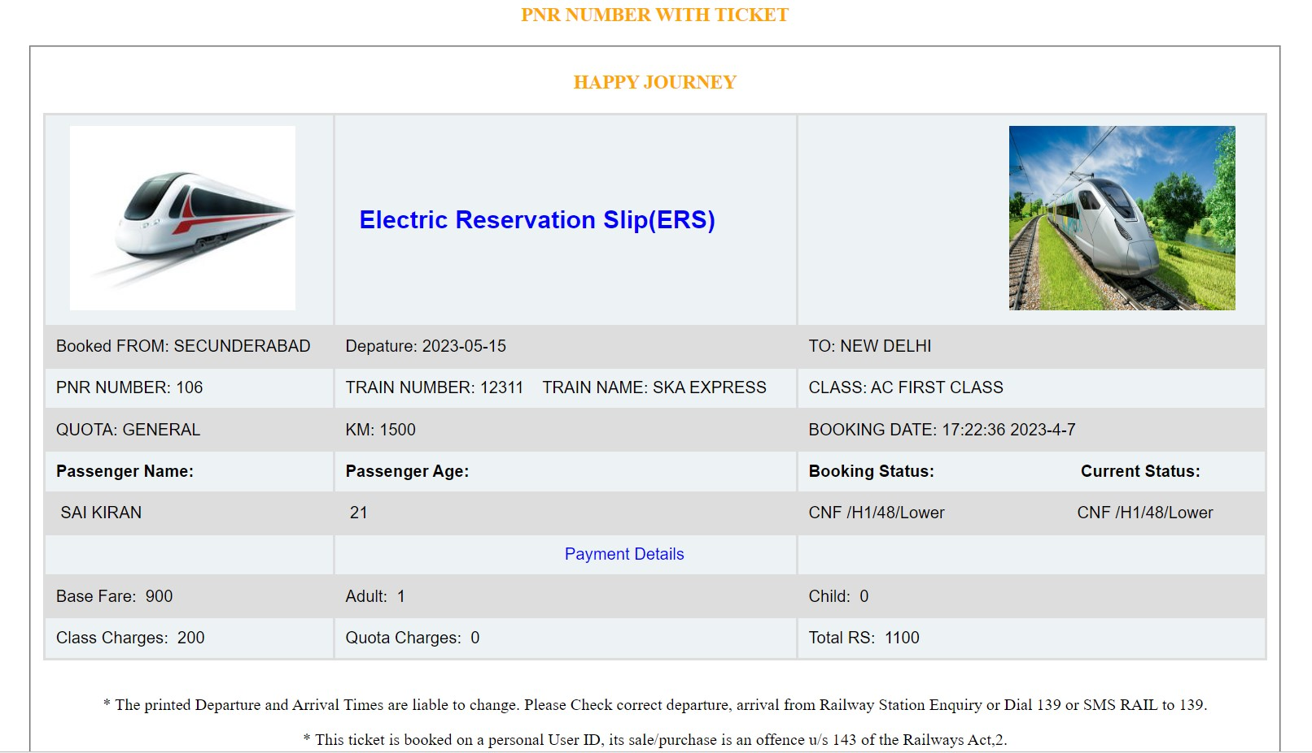

* After all User /Admin can logout his/her Session as shown below

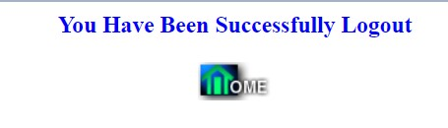

PROJECT SCHEDULING

I Estimate time and resources of this Project Train Ticket Reservation System project while scheduling project. All activities in project must be arranged in a coherent sequence that means activities should be arranged in a logical and well-organized manner for easy to understand. Initial estimates of project can be made optimistically which means estimates can be made when all favourable things will happen and no threats or problems take place.

In the Year of 2023 April to October 2023

|  |  |  |  |  |  |  |
| --- | --- | --- | --- | --- | --- | --- |
| Months | MAR | APR | MAY | JUN-JUL | AUG-SEP | OCT |
| Information Gathering |  |  |  |  |  |  |
| Requirements Gathering |  |  |  |  |  |  |
| Planning |  |  |  |  |  |  |
| Analysis |  |  |  |  |  |  |
| Design |  |  |  |  |  |  |
| Coding |  |  |  |  |  |  |
| Testing |  |  |  |  |  |  |
| Implementation |  |  |  |  |  |  |
| Documentation |  |  |  |  |  |  |

Benefits of online Train Ticket Booking

Many of us lead busy lives. Some of us are up before the crack of dawn, getting ourselves prepared so we can in turn get our families ready for the day. We rush to work, rush to get the kids to school, and at the end of the day we rush home only to brace ourselves for the next day. After a hectic day, the last thing you want to do is spend time waiting in line at the Railway station. That's where Online Train Booking comes in. Many of the benefits of doing our Train Ticket Booking online are obvious:

* You don't have to wait in line.
* You don't have to plan your day around the Railway station's hours.
* You can look at your train whenever you want, not just when you get a statement.

There are some hidden benefits too. As a young Train Reservation customer, you're just learning how to manage your Account and journey list observe your spending patterns.

* Online Train Ticketing allows you to watch your Train and train schedule on a daily basis if you want to. By keeping close tabs on your bookings, you'll always be aware of what's happening in your account.
* For those experienced spenders, this option is far more appealing than the sudden discovery that you're broke!
* It's also helpful to watch how much interest you're gathering on investments and Time saving or what service charges you have incurred.

Future Look

The “SKA Train Ticket Reservation System is a big and ambitious project. I am thankful for being provided this great opportunity to work on it. As already mentioned, this project has gone through extensive research work. On the basis of the research work, I have successfully designed and implemented booking System. To know what the future of online train booking looks like, it’s probably worth looking at the present – online booking isn’t new. When you think of online train booking, you probably think about a computer (either a desktop or laptop), a three or four step security process and then an interface that lets you view the balance of your various train users accounts and train scheduling, wish list permitting you to book a new train and whenever you want. And you’re not wrong either.

This project was developed to fulfil user requirement; however, there are lots of scope to improve the performance of the Online Banking System in the area of user interface, database performance, and query processing time. Etc. So there are many things for future enhancement of this project. The future enhancements that are possible in the project are as follows

We live in an era of online and digital banking. With Online Train Booking has made transactions easy, convenient and hassle-free. You can conduct various transactions using the bank's website with the train db. It also offers several other advantages. Online Train Booking not only provides you with ease of booking and greater accessibility but also offers you a host of other advantages. Here are five advantages of Online Booking that you should know-

* You can easily open an Online bank account. They are extremely simple to operate, and you can use it for various purposes that include paying your bills, transferring funds between multiple accounts to the train booking, etc. Thus, making payments faster. Online Banking can also help you view your transactions comprehensively and keep a record.
* You can perform your tasks from anywhere and at any time; even in the night when the bank is closed or on bank or public holidays. The only thing you need to have is an active internet connection, and you can easily transact 24*7, 365 days!
* It is fast and efficient. Your funds get transferred from one account train db. funds to the other very fast and without any hassle. You can also manage several accounts efficiently through internet banking.
* You can keep a watch on your daily transactions and account balance at all times. This facility also helps keep your account safe. You can also get to know about any fraudulent activity or threat to your account much before it can pose your account to severe damage, immediately, within a matter of minutes.
* More branches of the train booking, maybe it will be international, that means more Booking ATM machines outside.
* Customer issues development based on their needs, so the help desk will be aware of their needs and easy to use.
* Developing a mobile App for train booking system that help users to do the obtained his operations without go to the bank only he needs to sign in using his User Number/admin name. And password and then use your own PIN. Finally, the system will update automatically

• Integration with other bank and government agencies through Web Services • Connection to third-party OLAP applications

• Electronic Data Interchange (EDI) system for ATM machine

• Web Interface for net banking.

• In the area of data security and system security.

• Provide more online tips and help.

Conclusion

This project is developed to nurture the needs of a user in a train Booking sector by embedding all the tasks of transactions taking place in a Railway station. Future version of this project will still be much enhanced than the current version. Writing and depositing checks are perhaps the most fundamental ways to move place to place in and out of a checking account, but advancements in technology have added Railway ATM and Railway travelling pass. All Railway Stations have rules about how long it takes to access your Account, how many train booking transactions you're allowed in a day, and how much cash paid you for Ticket. Access to your Account checking for journey can also be limited by businesses that place holds on your funds. Banks are providing internet banking services also so that the customers can be attracted. To book the ticket online. youth and business man. Online Train booking is an innovative tool that is fast becoming a necessity. It is a successful strategic weapon for banks to remain profitable in a volatile and competitive marketplace of today. If proper training should be given to customer by the Railway employs to open an account will be beneficial secondly the website should be made friendlier from where the first-time customers can directly make and access their accounts. Thus, the Train Ticket Reservation System it is developed and executed successfully.

SKA Train Booking System Versions

THE SKA TRAIN Reservation System V 2.0

In this version here just modified the session files that are written in the single page

with simple code complexity

Version 3.0

In this version mainly focused on the java script as a main file for index and user admin ui time running and date

Version 3.1

Added the extra program for the admin to know the fund in the db ie reservation and general ticket

version 4.0

Added the Gender to the reservation for both user and admin and code simplicity.

Restricted if the User don’t have any sufficient fund to book the ticket it will display the No balance in AC message.

Version 4.1

In this Version Restricted the Ticket Printing that when User Wrongly entered the password to print the tickets

and modified the admin and user UI logins

Version 5

In this Version Rectified the sitting system for the passengers book a ticket more than one person will get a separate seat

Code Complexity.

Version 6

in this version included the Date& Time formats that are 15-Mar-2024 and time format 12:20:22 AM

Which Will simplify conversion of string times into time formats and date format

Version 7.0

In this Version included the e-ticket cancellation for both user and admin the ammount of ticket will be credited into the user account the same account used while booking a ticket and with printable cancellation ticket with added 3-4 coloums in train_reservation table

here we can also see the status of a resrvation is it CAN or CNF

in this version auto redirection added after a 5 seconds the page will automatically redirects to the another page withput clicking the print button while reservation and cancel e ticket

Version 8.0

In this Version included the automatic passenger increases when clicks on the add+ new passenger

this will solved the issue with the credability of passengers when ticket booking

here also included the automatic letters to capital when user enters a passenger name even for admin

for this we used the code

Sting s="hyderabad";

s.toUpperCase();

also included the payment mode that will display in the ticket

also in this version validated the things that are cancelled tickets will not be cancelled again....

and cancelled tickets are now separeted with Confirmed tickets user/admin will know the status of booking

if user cancelled the ticket the cancelled tag CAN will displayable when printing the ticket

lot of development done in this version of SKA-TRAIN-RESERVATION-SYSTEM.....

THE SYSTEM ARCHITECTURE SKA TRAIN

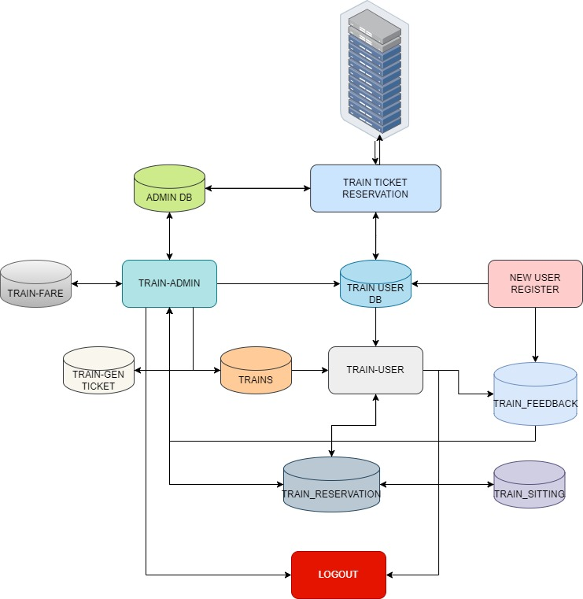

Screenshots

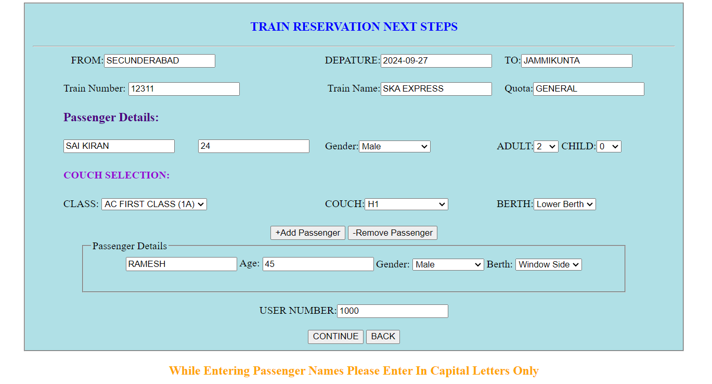



s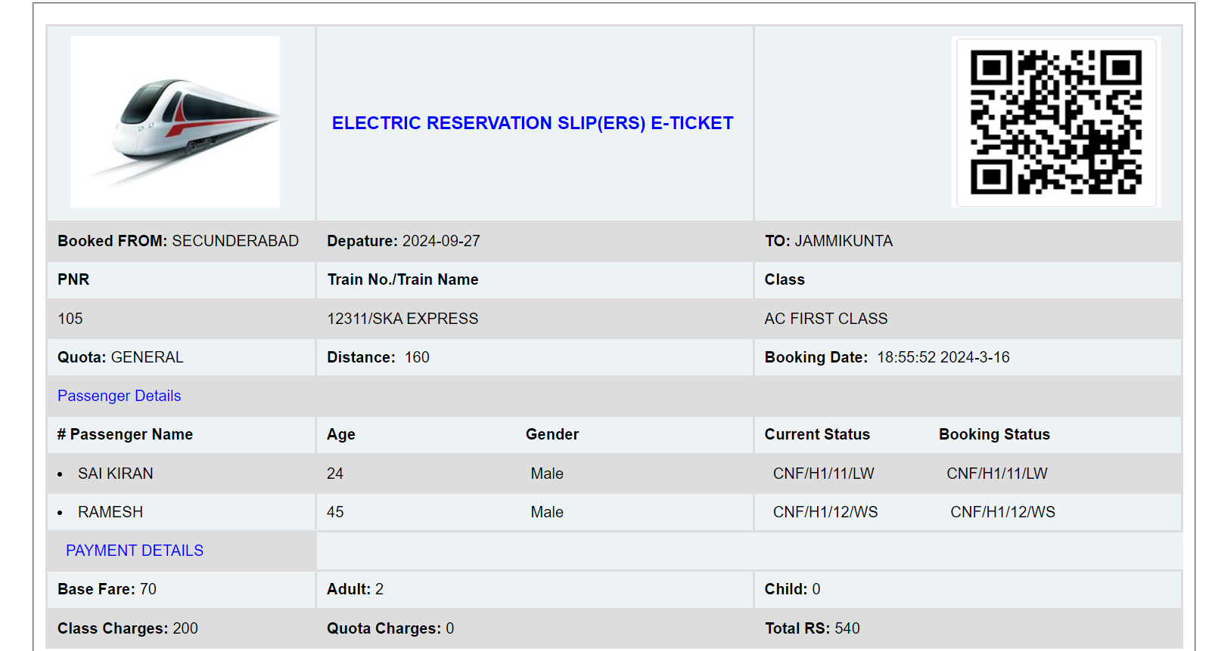



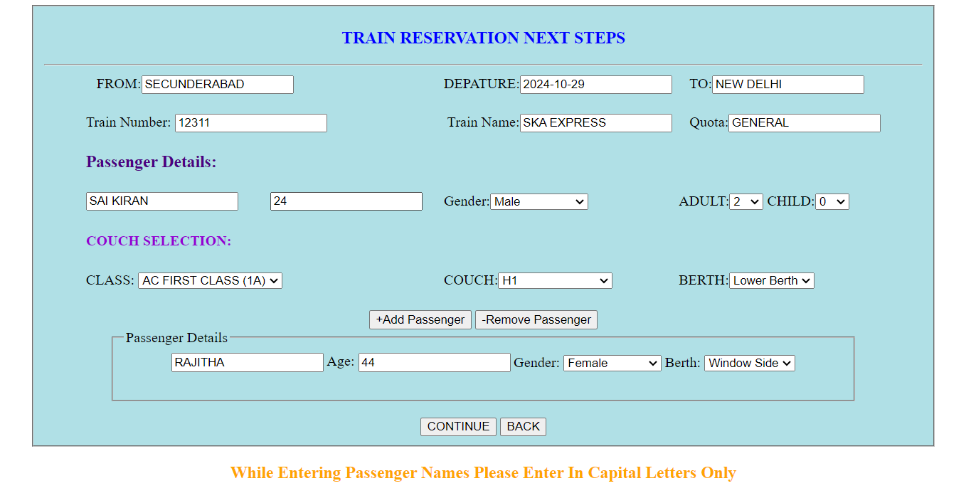



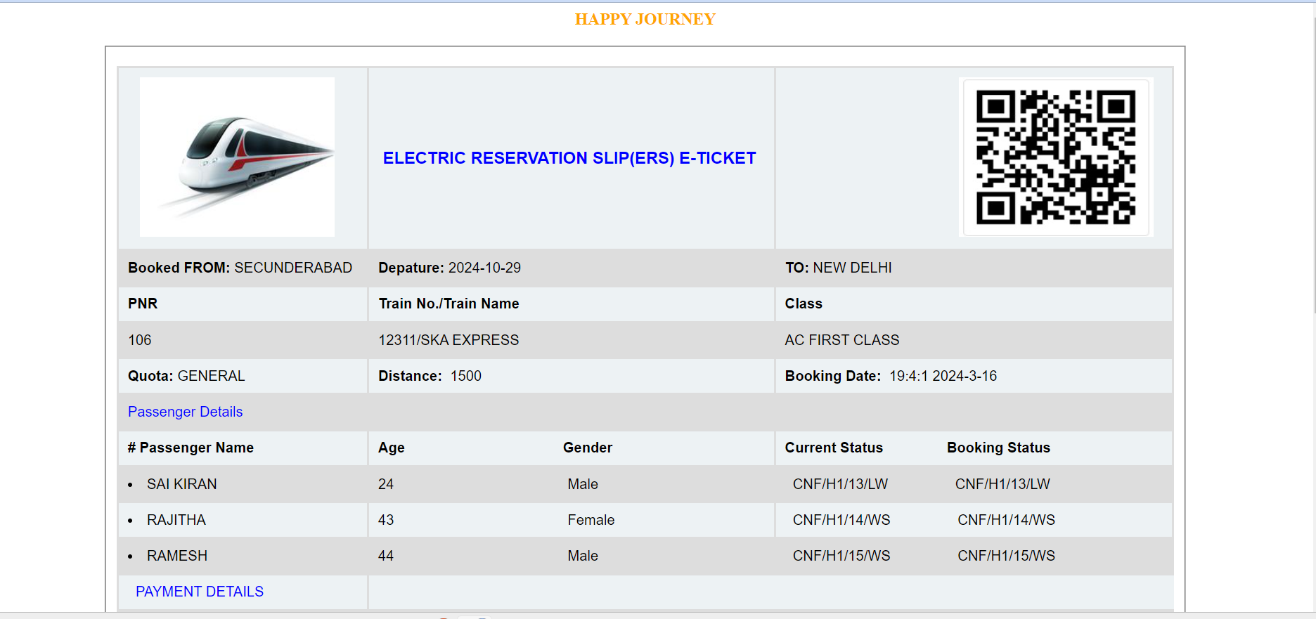



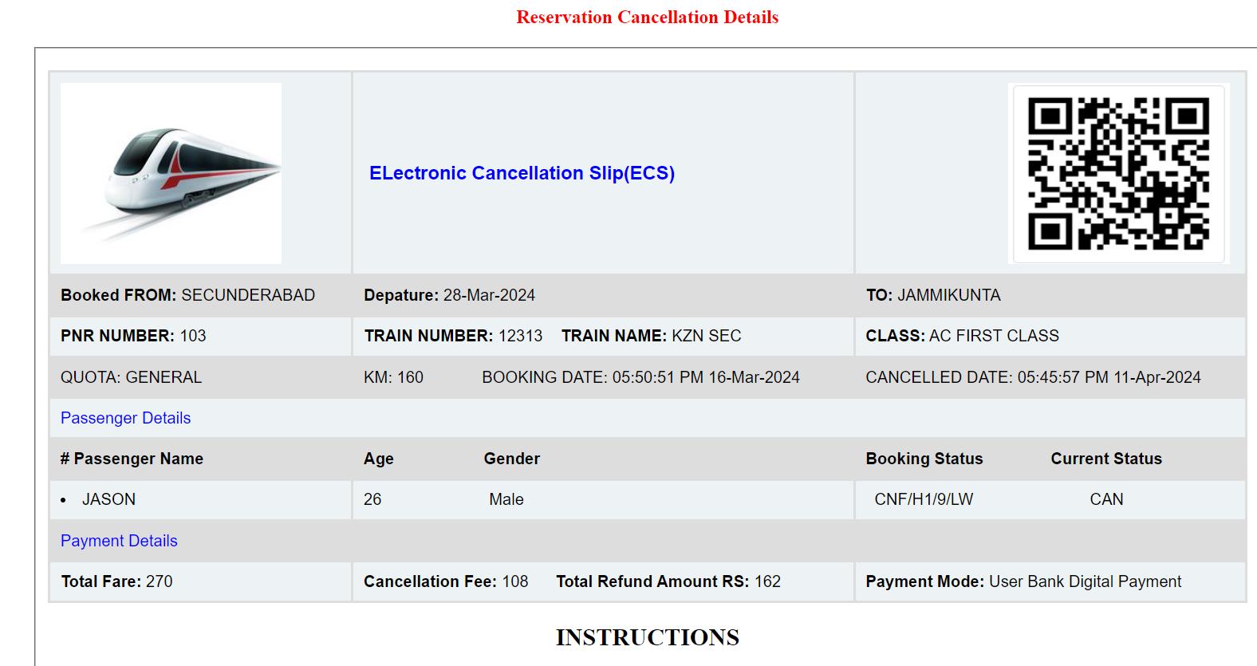



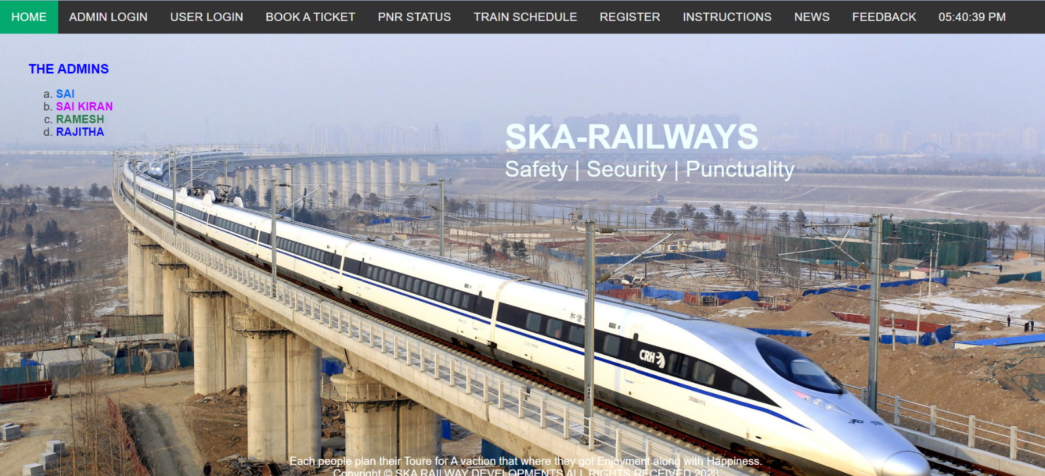



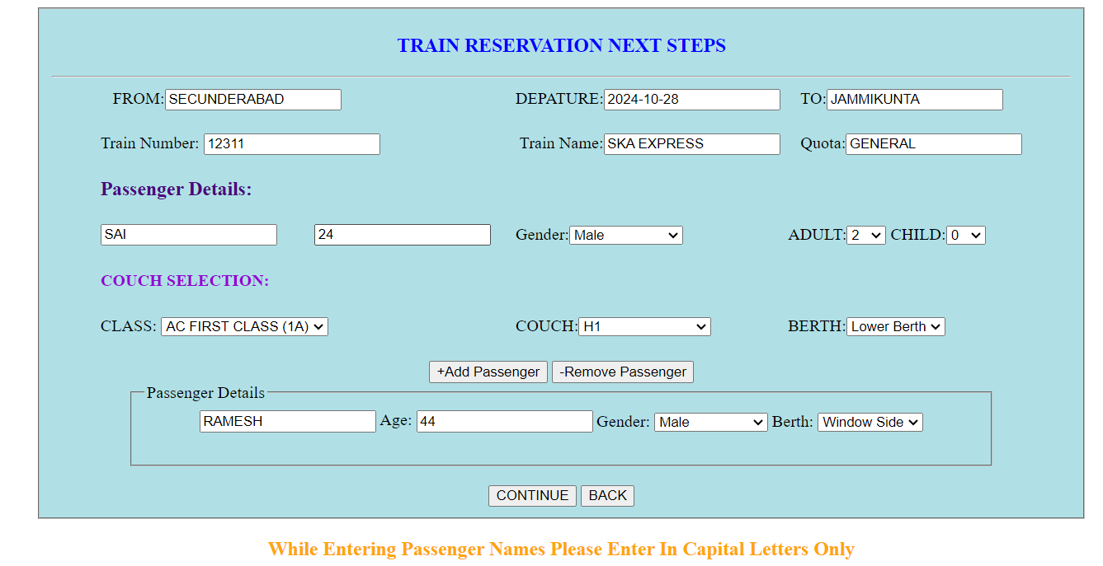

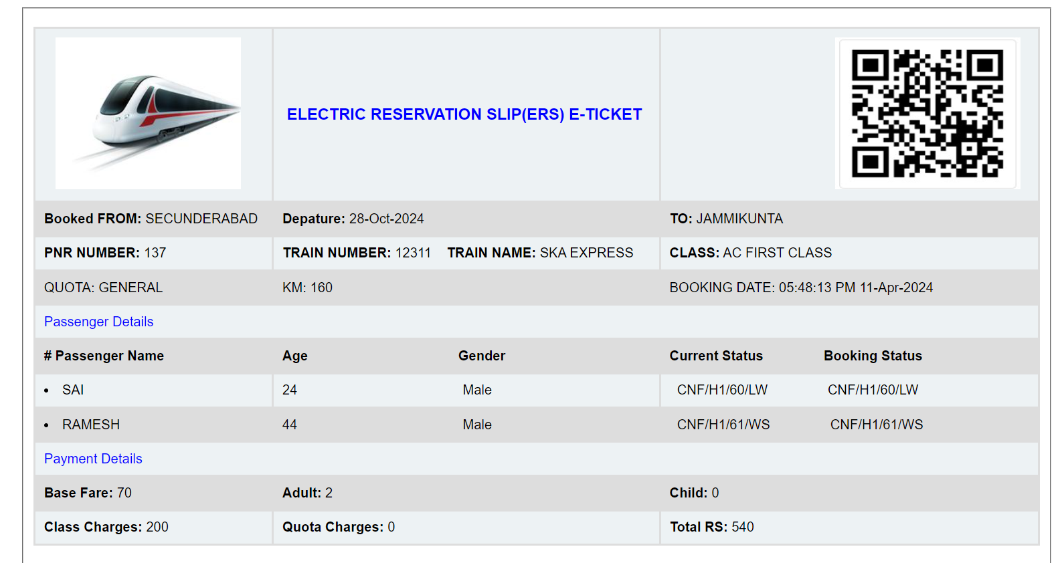

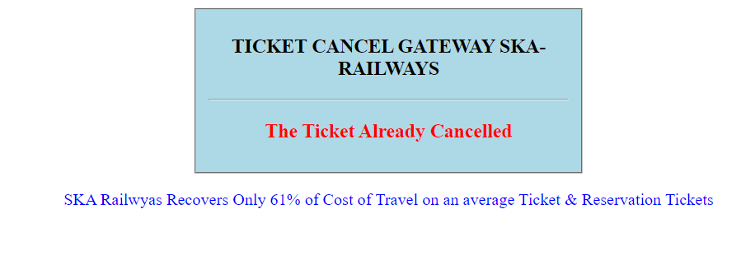

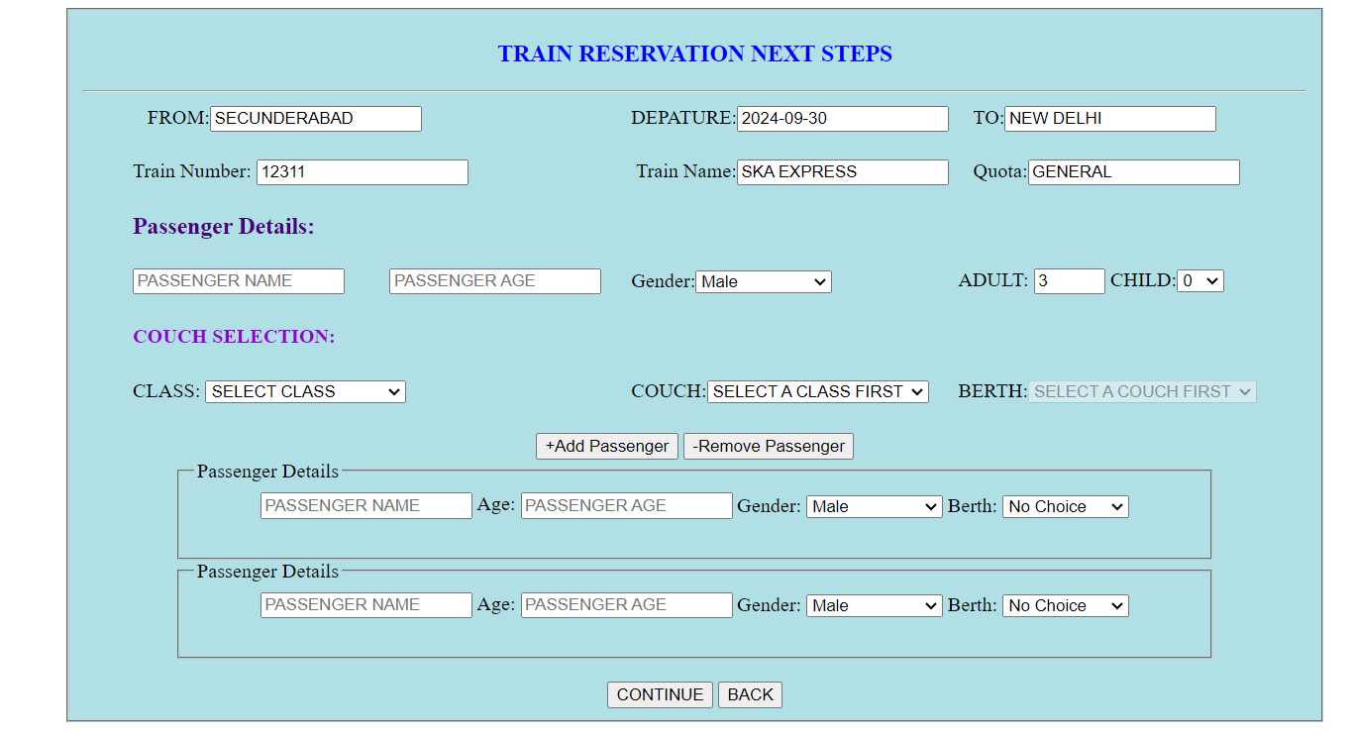

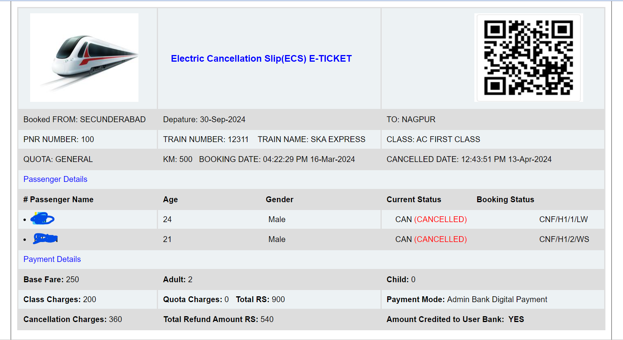

PROJECT SUGGESTIONS

* System Architecture & Design by the Developers of System Admin
* System Design: System Developer
* Database Design: System Developer
* Bank Gateway: Union Bank Manager Pranay Vavilala
* Reservation System Sitting with PNR: Devendra Jannu
* Reservation System Schema: Pathakani Vandana
* Reservation Cancellation System: Kandukuri Sindhu
* User Reservation System: Gaddameedi Sai Karthik
* Reservation Data List: M. Arun Kumar
* Reservation Train Selection: JS Curd Operations W3 Schools & Geeks for Geeks
* Empty Field Validations: System Developer
* System Schema & Server: System Developer

Reference

Learning MYSQL, JavaScript, jQuery, PHP, HTML, CSS3, Website: <http://www.w3schools.com>

JavaScript validation for empty input field, (May 10, 2015) Website: <http://stackoverflow.com/questions>

Online UML Diagrams <https://app.diagrams.net/?libs=general;er>

Inserting Dates to Database <https://stackoverflow.com/questions/39032973/inserting-date-field-into-database-using-jsp-with-different-date-formats>

Tomcat Custom Page Redirection for Internal Server Error 500 <https://stackoverflow.com/questions/39032973/inserting-date-field-into-database-using-jsp-with-different-date-formats>

Article on Beware of Online Phishing Sites/E-mails <https://consumer.ftc.gov/articles/how-recognize-and-avoid-phishing-scams>

Article for the Train Booking <https://timesofindia.indiatimes.com/travel/topic/train-ticket-booking/articles/4>

Railway Sections <https://indianrailways.gov.in/railwayboard/view_section.jsp?lang=0&id=0,1,304,366,523,2530>

Railway Rules <https://www.railrecipe.com/blog/train-travel-rules/>

THE-END